

-



**Advance Data Science**

**FDA Adverse Event Reporting System**

**(FAERS)**

**Final Project Report**

**Team 5**

Ankit Bhayani

Rajat Agrawal

Vishakha Sawant

SUMMARY

The report summarizes the analysis performed on FDA Adverse Event Reporting System, provided byFDA: <https://www.fda.gov/Drugs/GuidanceComplianceRegulatoryInformation/Surveillance/AdverseDrugEffects/ucm082193.htm>

We then build multi-class classification machine learning models using the datasets to classify the outcome of the drug prescribed by the health professional and reaction associated with the drug. The problem presented is divided into 4 sections:

**Section 1: Data wrangling**

* Data Download and pre-processing
* Exploratory Data analysis on Tableau

**Section 2: Dockerizing the whole Process**

* Luigi Pipeline
* Docker Image on Ubuntu
* Result on Amazon S3

**Section 3: Building and evaluating model**

* **Classification** using Multi-Class Logistic Regression, Multi-Class Random Forest, Multi-Class Neural Network, One vs All Multi-Class SVN Algorithms

**Section 4: Creating User Interface for the FDA/Health Professional & User (Patient)**

* **FDA/Health Professional:** will use the user interface to predict the probability of the drug reaction -outcome based on certain parameters
* **User (Patient):** Can search for adverse drug reaction which can be caused through a drug

**NOTE: Outlook details for Azure Model**

User Name: [ads_team5@outlook.com](mailto:ads_team5@outlook.com)

Password: spring2017

1 PART 1: DATA INGESTION AND WRANGLING

1.1 THE DATA

***FAERS (FDA Adverse Event Reporting System) Dataset***

The FDA Adverse Event Reporting System (FAERS) is a database that contains information on adverse event and medication error reports submitted to FDA.The FDA produces [FDA Adverse Event Reporting System (FAERS)](http://www.fda.gov/Drugs/GuidanceComplianceRegulatoryInformation/Surveillance/AdverseDrugEffects/ucm082193.htm) quarterly data. The FAERS include the following:

* demographic and administrative information and the initial report image ID number (if available);
* drug information from the case reports;
* reaction information from the reports;
* [patient outcome information from the reports;](http://www.nber.org/data/fda-adverse-event-reporting-system-faers-data.html#outc)
* [information on the source of the reports;](http://www.nber.org/data/fda-adverse-event-reporting-system-faers-data.html#outc)
* [a "README" file containing a description of the files.](http://www.nber.org/data/fda-adverse-event-reporting-system-faers-data.html#outc)

The FDA provides a lot of [additional information](http://www.fda.gov/Drugs/GuidanceComplianceRegulatoryInformation/Surveillance/AdverseDrugEffects/default.htm) about the FAERS. FDA Adverse Event Reporting System (FAERS) began 2012Q4.

[Legacy Adverse Event Reporting System (AERS)](http://www.fda.gov/Drugs/GuidanceComplianceRegulatoryInformation/Surveillance/AdverseDrugEffects/ucm083765.htm) are available 2004Q1-2012Q3. we have used FAERS variable names in the AERS files in cases where the variables are the same.

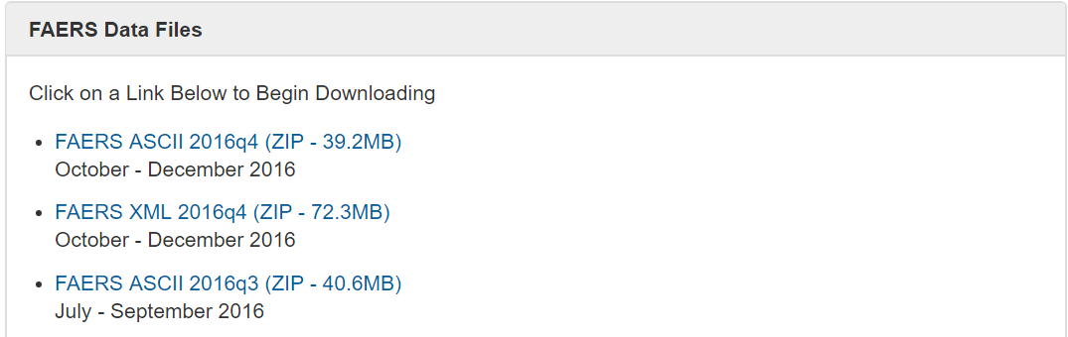

**Data Download and pre-processing:**

The very first challenge was to programmatically download the data from FDA website (<http://www.fda.gov>), download and preprocess the “FAERS” data file starting from Q4 2012 till Q4 2016.

To download the file programmatically, without any manual intervention we have used the python requests library to navigate to the website and created source directory (FAERSsrc), where all the related files will be downloaded and destination directory where all the files required for our analysis will be saved.

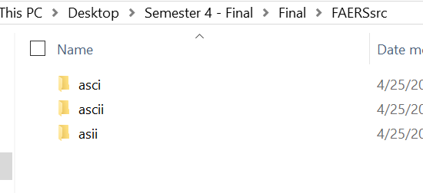

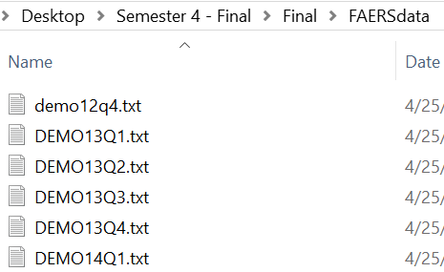

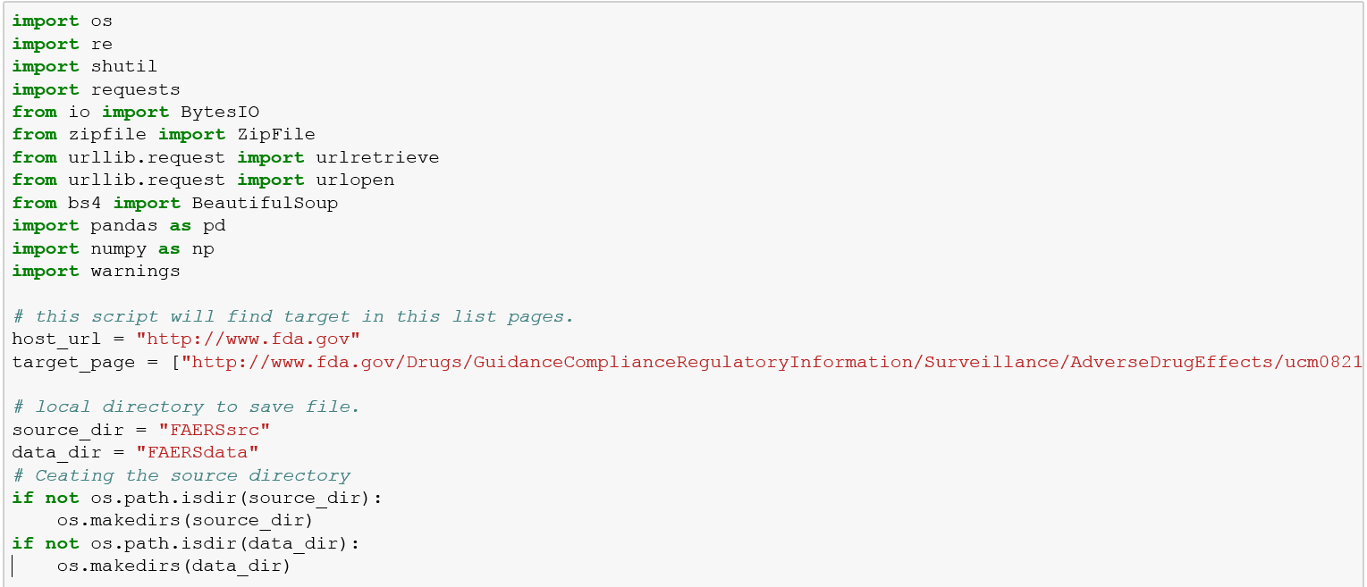

We will be using **Beautiful Soup** package, a powerful python package for data scrapping from the FDA website and download all the quarterly files for the “FAERS” files for our analysis purpose.

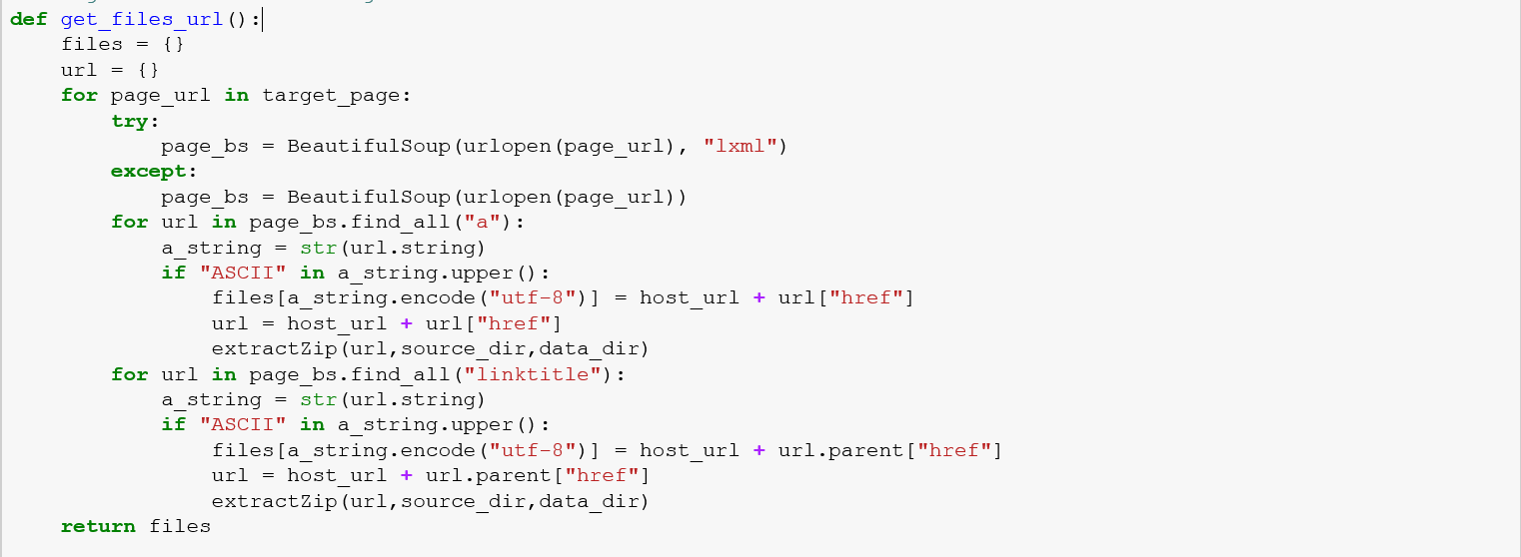

After getting the files from the FDA website, we will download all the quarter file in unzipped formed on our local and delete all the irrelevant files which are not required for our analysis. For handling this, we have a deleted the files in XML (present in pdf format) format and ReadMe files.

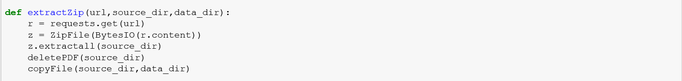

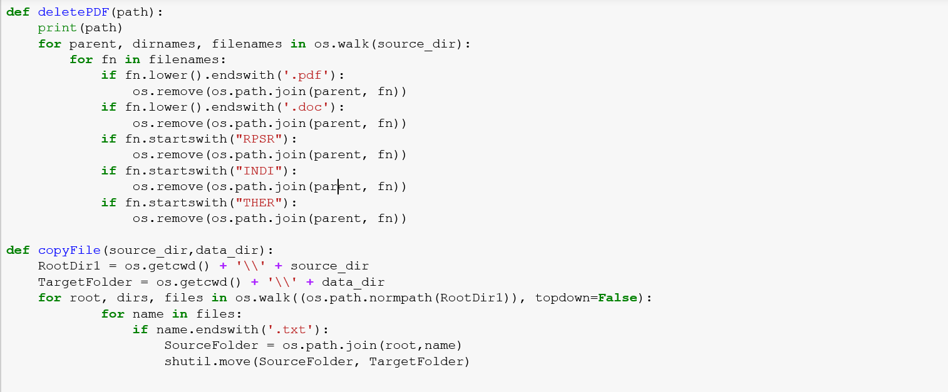

As we will have files in different folder depending on the quarter data, we will move all the required file into a destination folder. The files which are using for our analysis are:

* demographic and administrative information and the initial report image ID number (if available);
* drug information from the case reports;
* reaction information from the reports;
* [patient outcome information from the reports;](http://www.nber.org/data/fda-adverse-event-reporting-system-faers-data.html#outc)

1.2 Data Preprocessing and Cleaning

Since we are working on quarterly data set, we need to merge all the data from all the quarter to create a single data set for our model training and testing. To achieve this goal, we will join our data present in four different file into one frame based on the primary reported Id and case Id.

We start with the demographic file and join the data of this file with the drugs reported based on the keys, which will be joined with the reaction dataset and the outcome of a drug and reaction.

**DEMO.TXT**

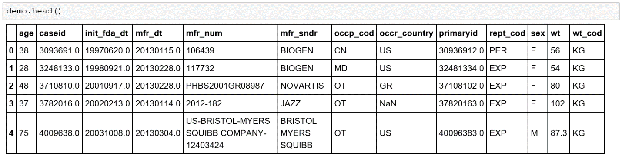

We have many Null values and spaces (an invalid values) which we need to handle before using these files to create a final dataset. We must make sure that our data is in proper format with same datatype. Since we have large amount of data to be processed, we choose to keep only those rows where we have all the details related to Drug and their adverse react.

**DRUG.TXT**

Drug files consist of all the drug which are reported to FEARS database with the dosage type, amount. Dosage form and other details related to the drug.

NOTE: Since we have millions of drugs reported, we have taken only those drugs which are reported as primary suspect for causing the reaction.

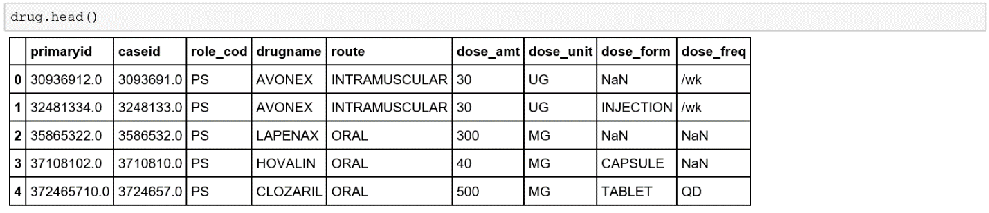

As we have many empty column values in our drug file, we need to clean those to ensure that we don’t have any NAN/NA value in our data. Also, we need to take care of the data type of column. These columns will be required for creating the final dataset.

**REACTION.TXT**

Reaction files consist of all the reaction reported based on the number of drug associated with the case Id. With one drug, we have many associated reactions which are reported to FAERS database. We don’t have any Null/NAN values in the reaction files.

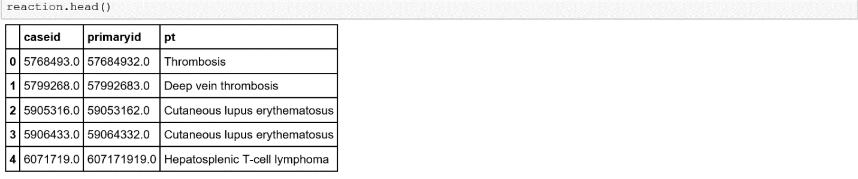

**OUTCOME.TXT**

Outcome files consist of the outcome reported based on the number of drug and reaction associated with a case Id. We don’t have any Null/NAN values in the outcome files.

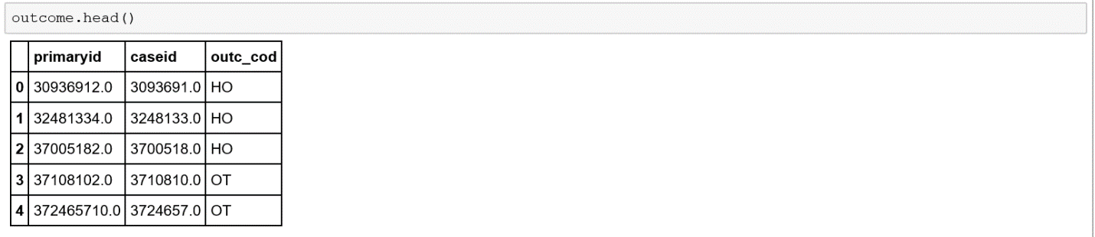

We have used the standard Reaction Name as proposed by **MedDRA or Medical Dictionary for Regulatory Activities** which is a clinically validated international medical terminology dictionary used by regulatory authorities in the pharmaceutical industry.

For Drug Name standardization, we have used **RxNorm** provides normalized names for clinical drugs and links its names to many of the drug vocabularies commonly used in pharmacy management

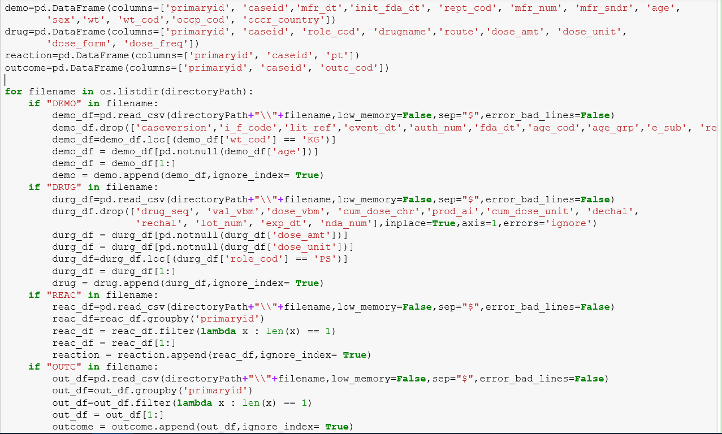

Once, we are done with the cleaning of all the four files, we will create a summarized data set using the python joins file based on primary report id and case id. For this step, we created a function which will join all the four-data frame associated with the final data set.

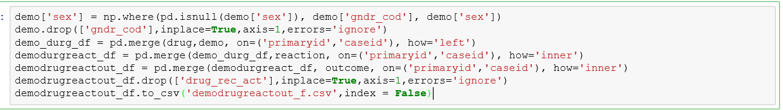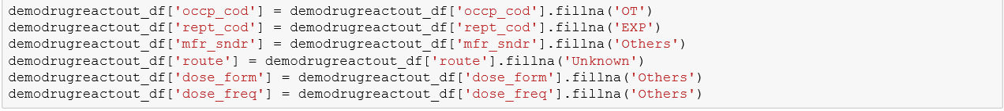

1.3 Creating Cleaned FAERS Dataset CSV file (Output)

The result will be a joined dataset consisting of all the details of Drug, Reaction and their outcome

in a csv formed.

PART 2: Exploratory Data Analysis

2.1 Analysis - Tableau

The first dashboard **FAERsDataset- DrugReaction Effects** Analysis have 4 tableau sheets which are interactive and driven with selecting a Drug from Drug Counts sheet.

* **Drug Counts**: contains the top 25 drugs by count present in the FAERs database. Also, a specific drug or multiple drugs can be selected from the search bar with Drugname label.

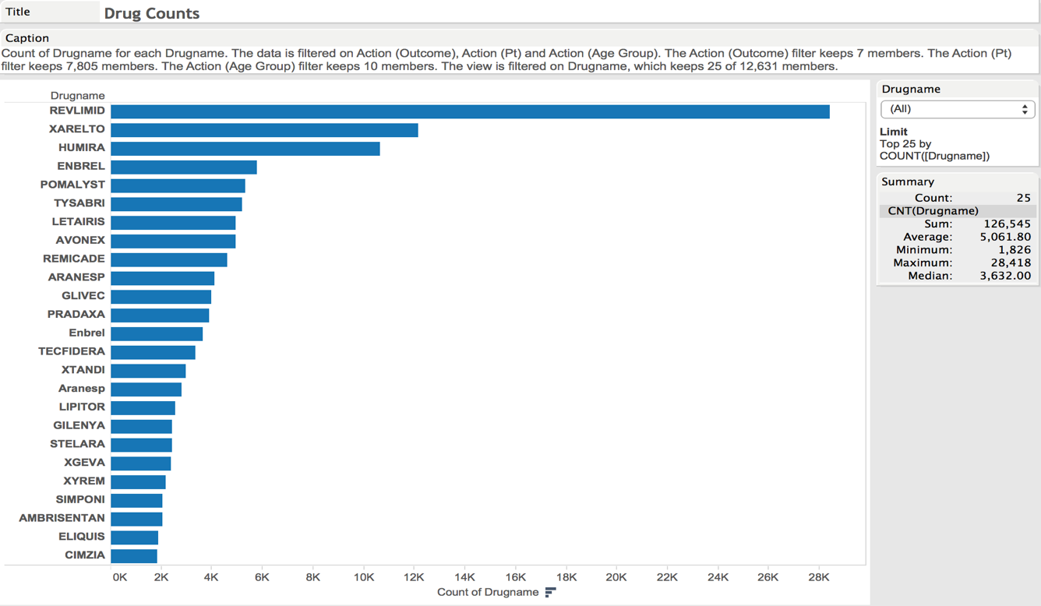

* **Reaction analysis**: This sheet gives the list of possible reaction can be occurred after selectin a drug and corresponding % amount.

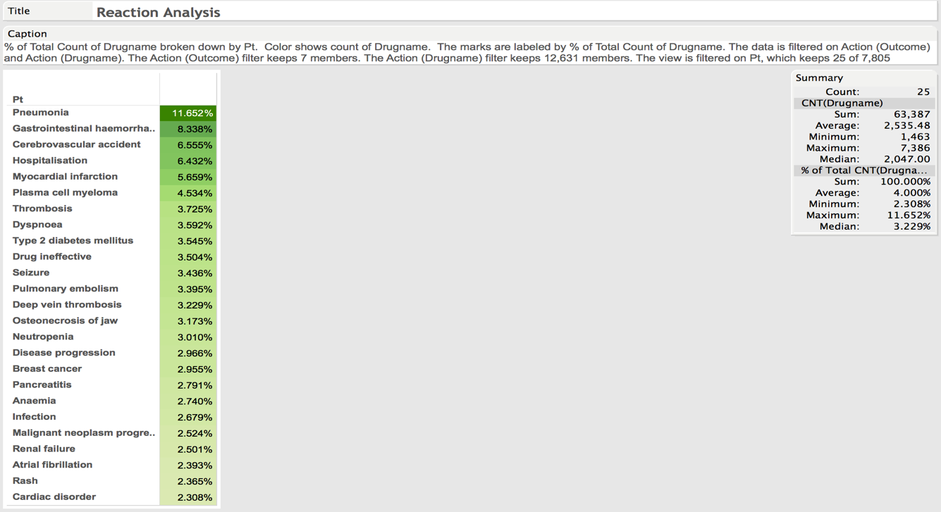

* **Outcome distribution**: provides you the percentage of the outcome distribution on the basis of existing data.

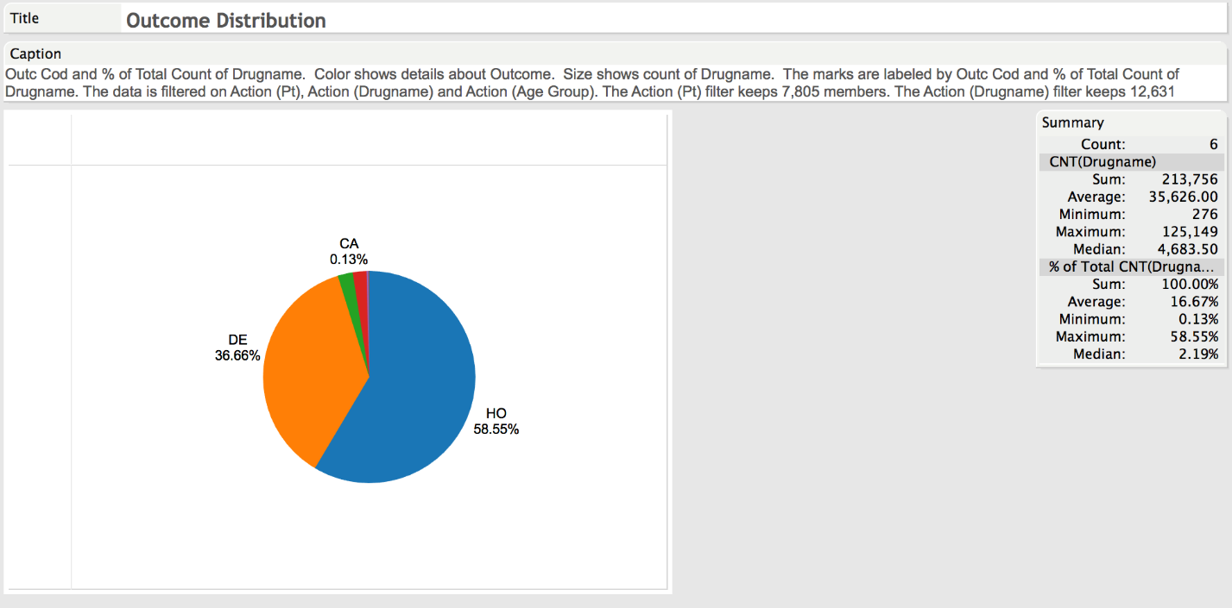

* **Demographic analysis**: Presents the percentage amount by country where the event has occurred over the past years.
* 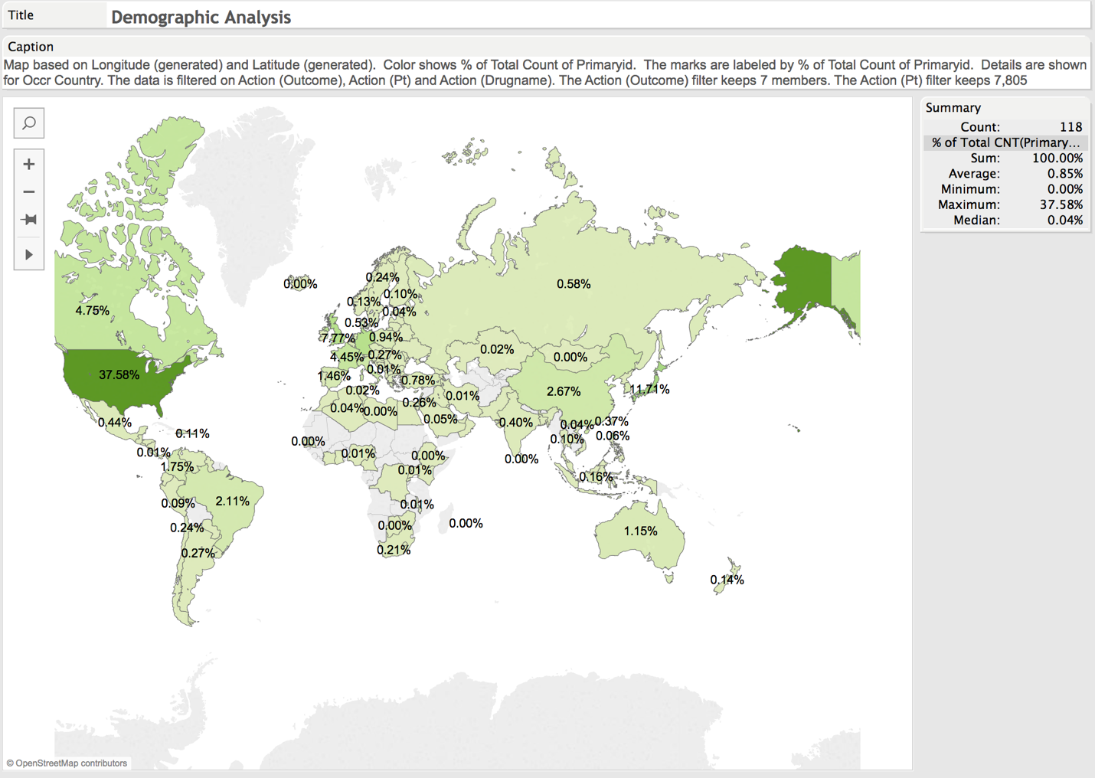

# **FAERsDataset- DrugReaction Effects Analysis Dashboard:**

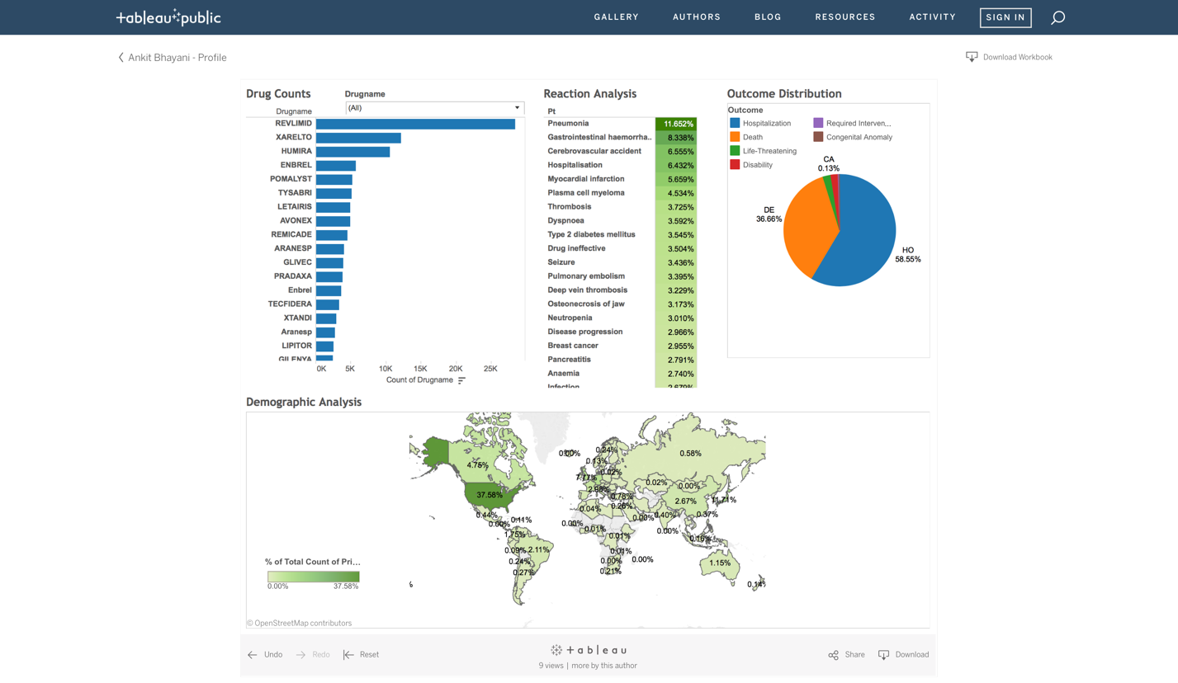

**Use cases:**

1. Selecting GLIVEC drug gives the following distribution:

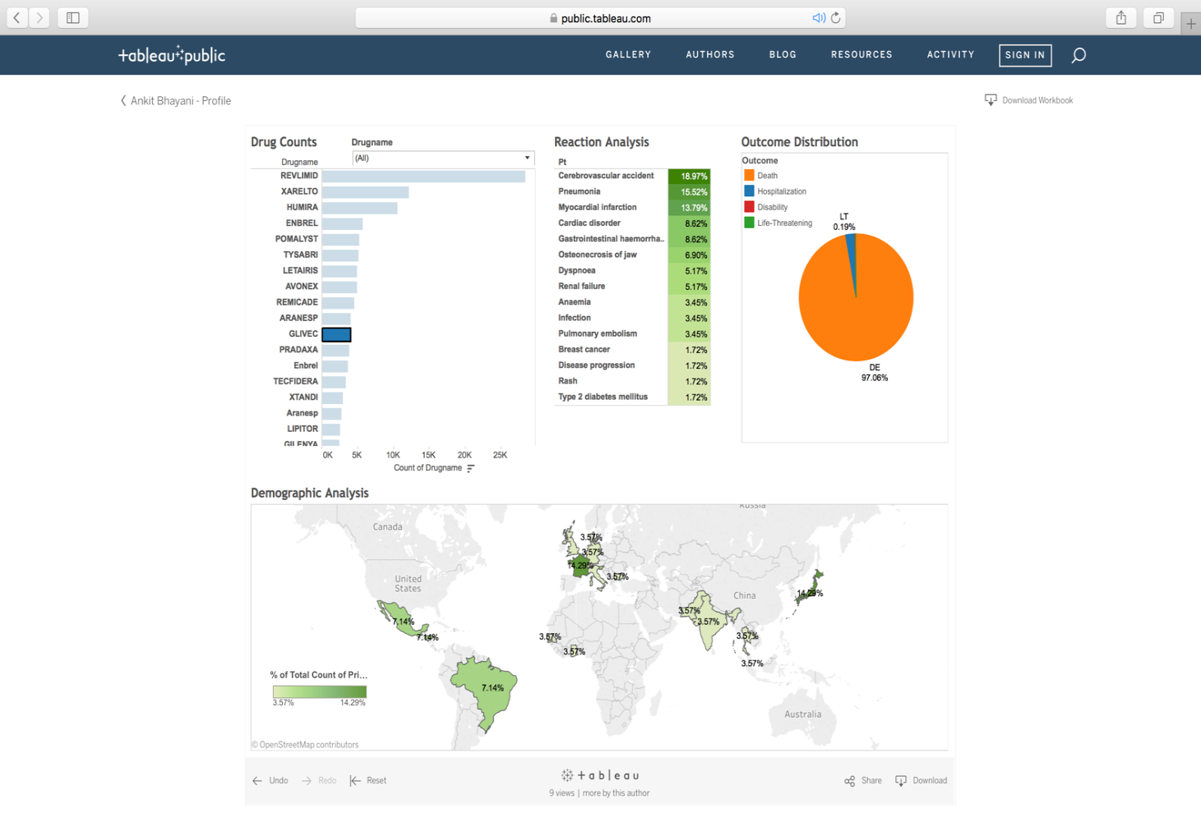

1. Selecting HUMIRA drug gives the following distribution:

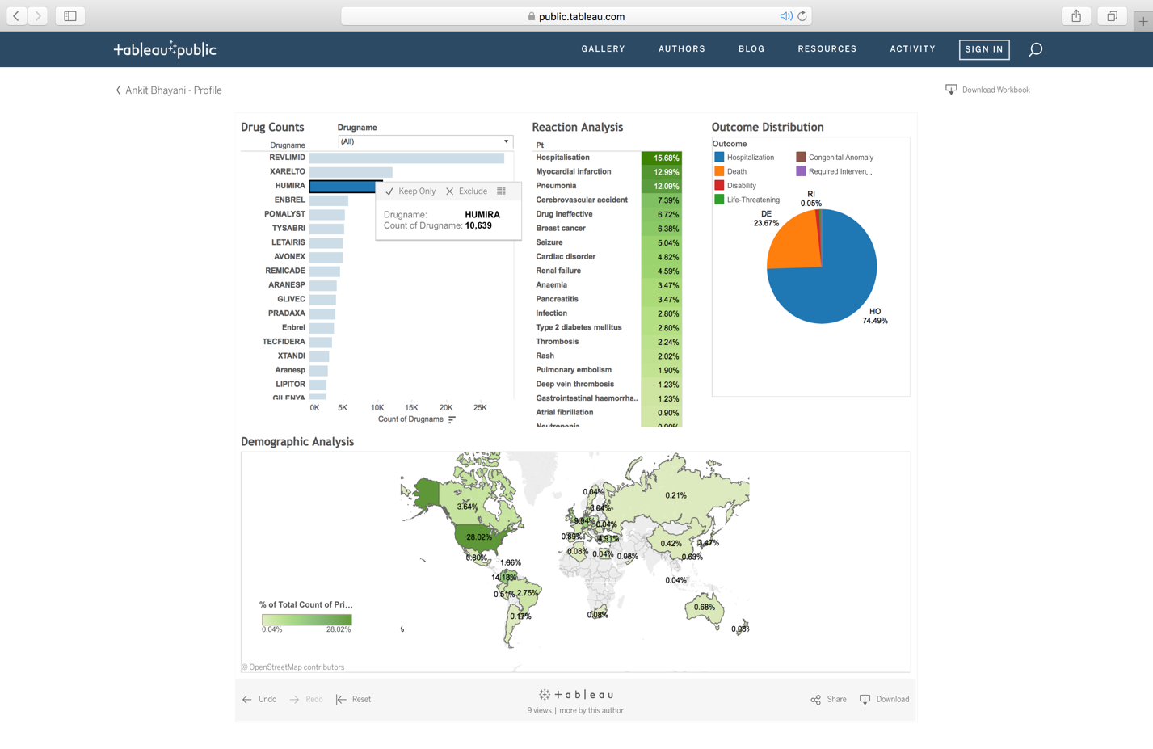

Second dashboard ***FAERsDataset- Outcomes on AgeGroup, Gender and Manufacturer*** talks about outcomes based on the following criteria:

* Age group – Driving sheet (all the filter is driven with this sheet) contains 9 class based on the different ages:

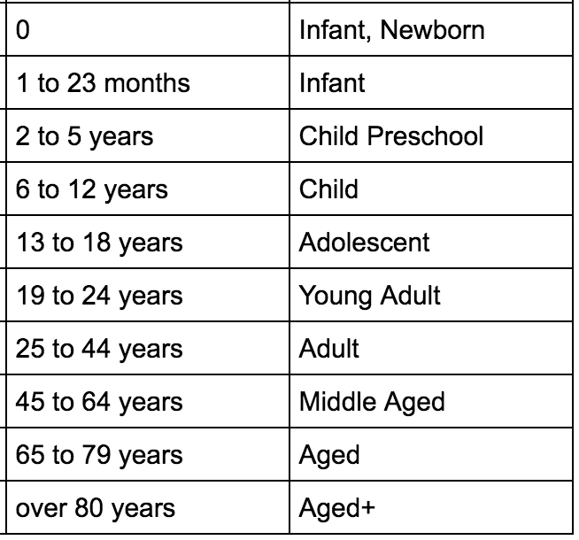

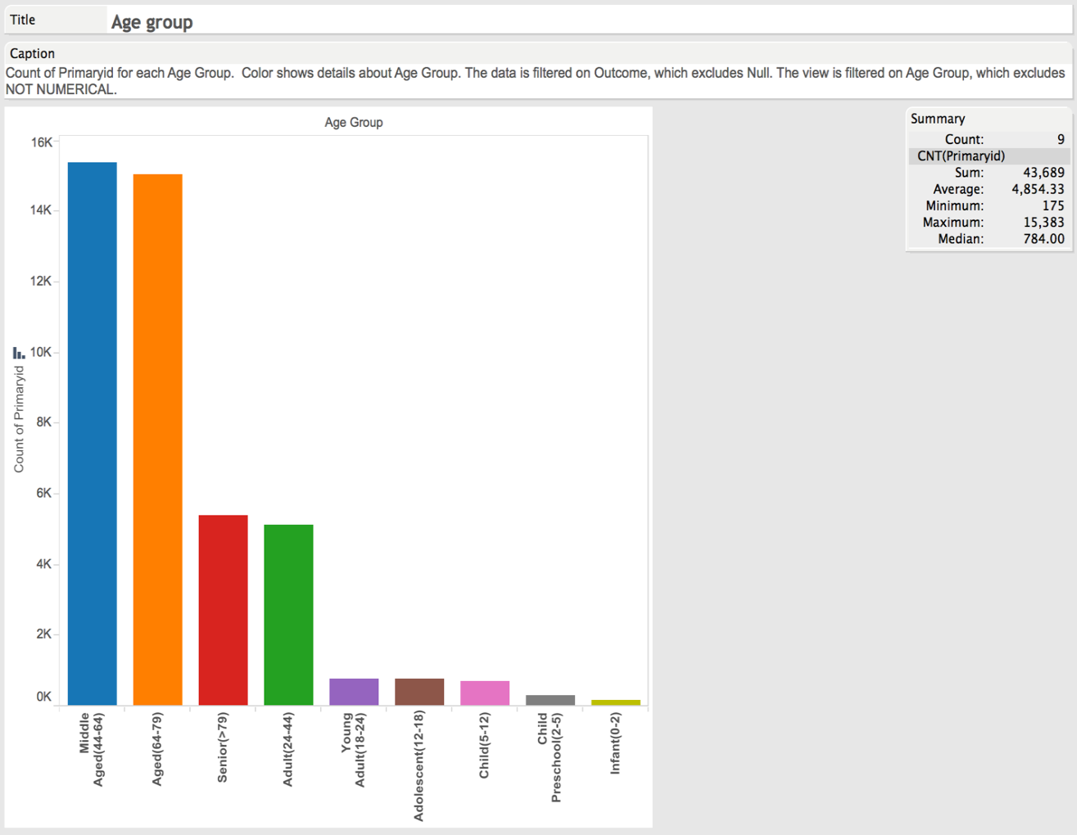

* **Gender** – gives you the % amount about the gender category.

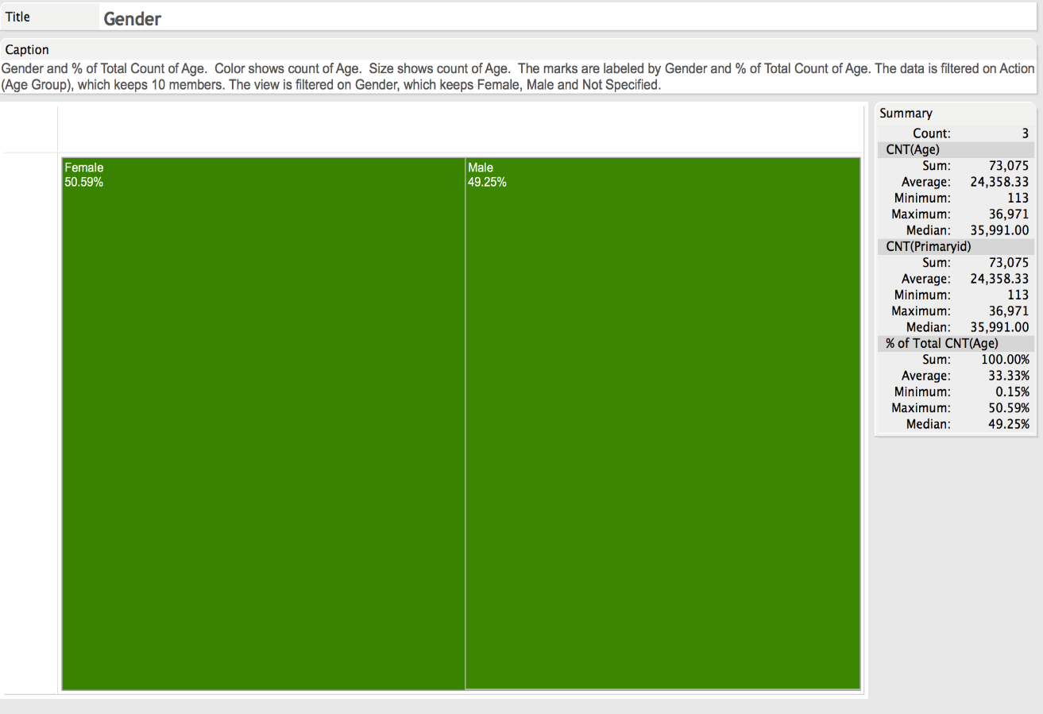

* Manufacturer distribution – Top 10 Manufactures which have been reported and % amount by cases received.

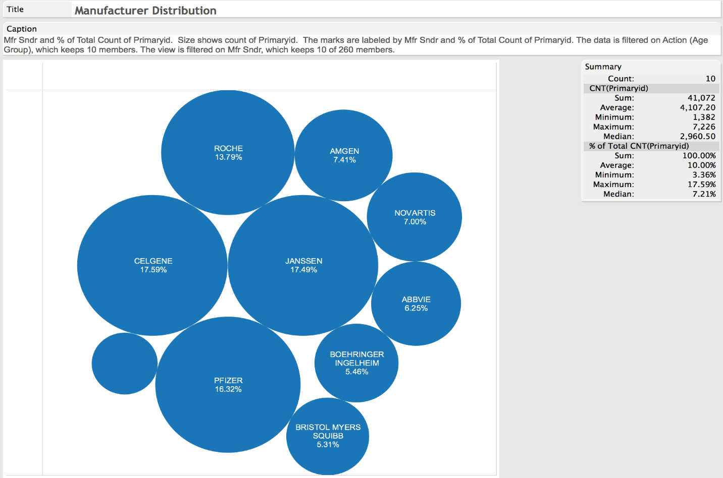

# **FAERsDataset- FAERsDataset- Outcomes on AgeGroup, Gender and Manufacturer:**

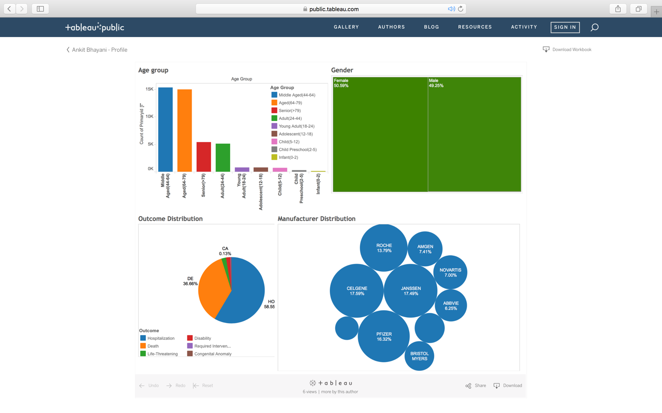

Use cases:

1. Selecting Aged gives:

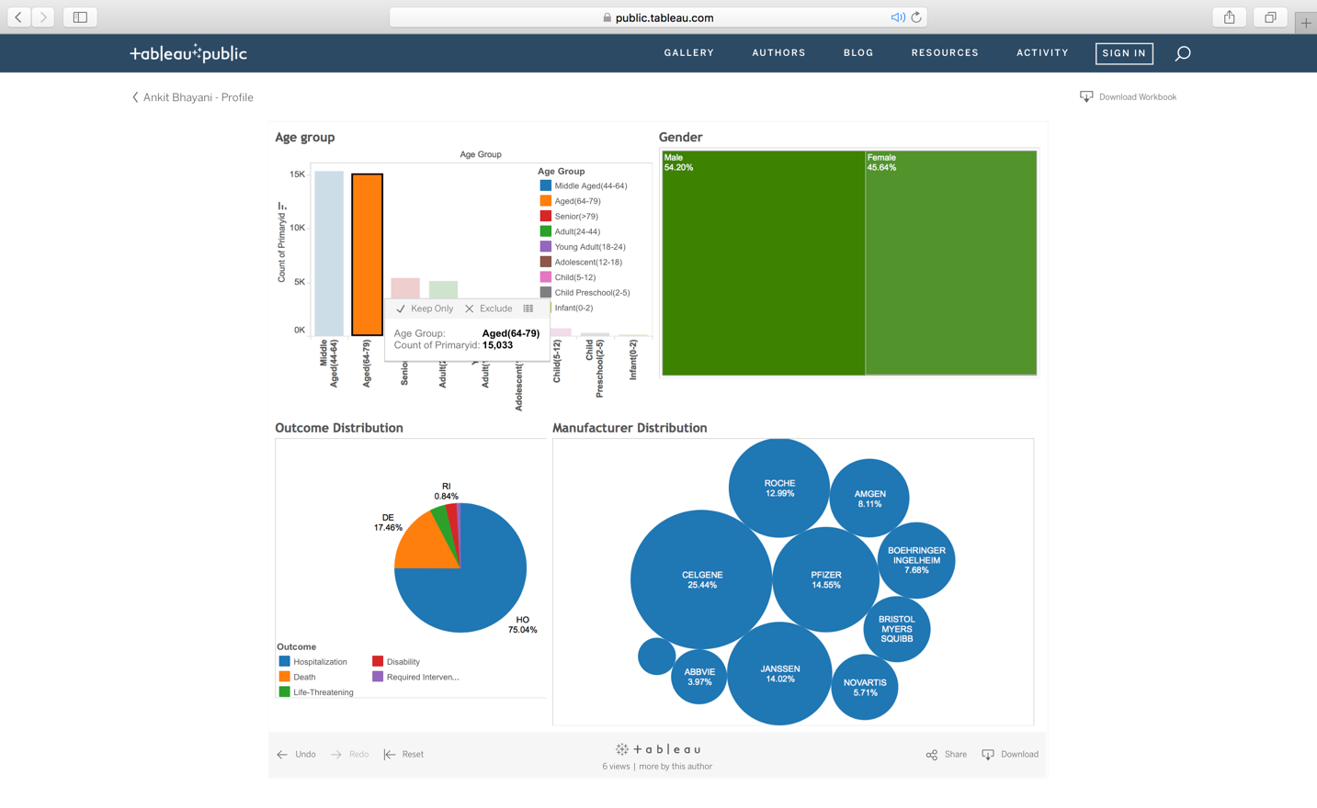

1. Selecting Adult gives:

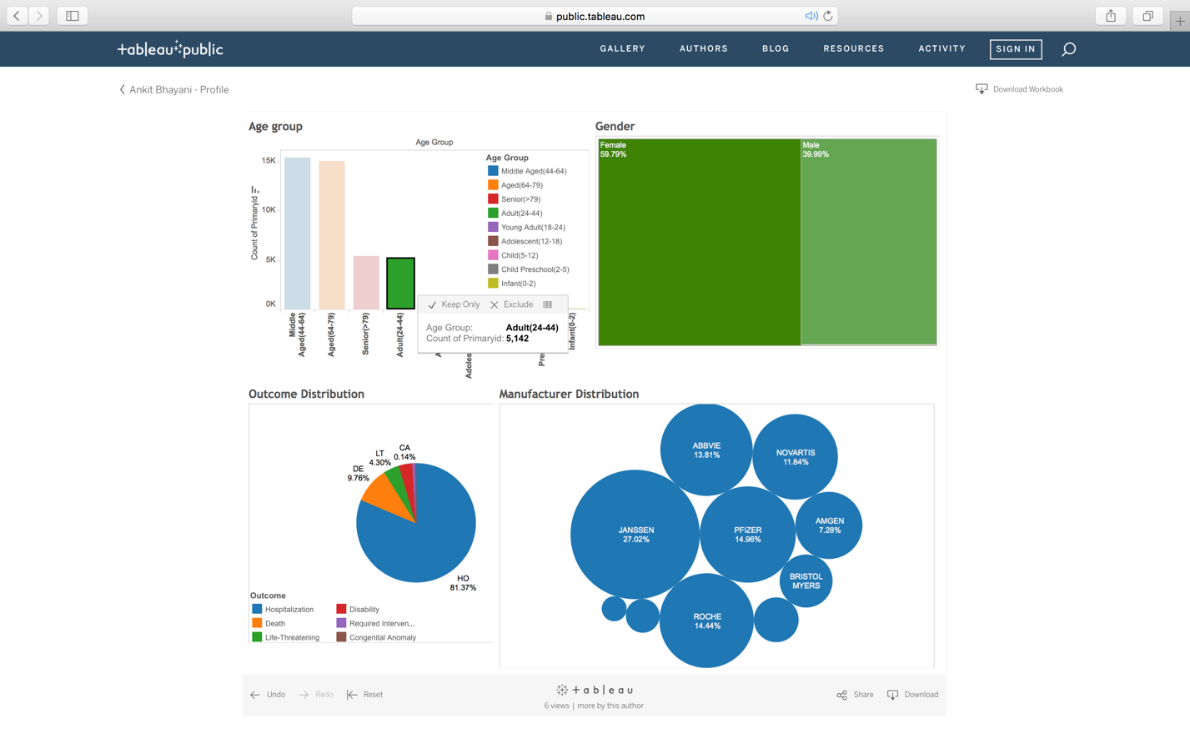

PART II: DOCKERIZING THE PROCESS

**PIPELINING THROUGH LUIGI**

Luigi is a Python-based framework for expressing data pipelines. Everything in Luigi is in Python.

Luigi performs following functions in a pipeline for downloading and creating the processed-out file:

1. get_files_Urls-Fetching urls for file download
2. mergeData-Merging and Cleaning all the data from all downloaded file into a single file

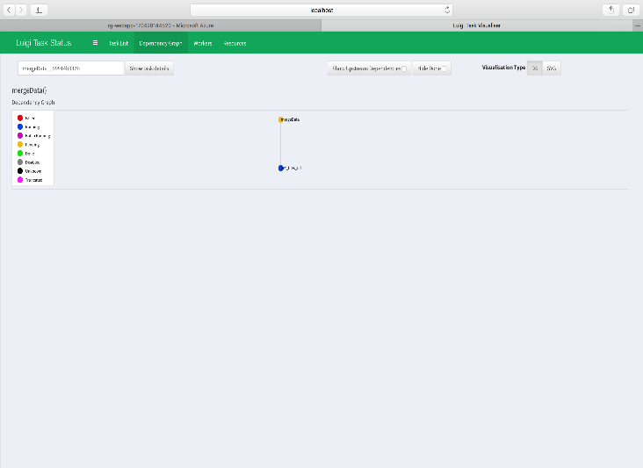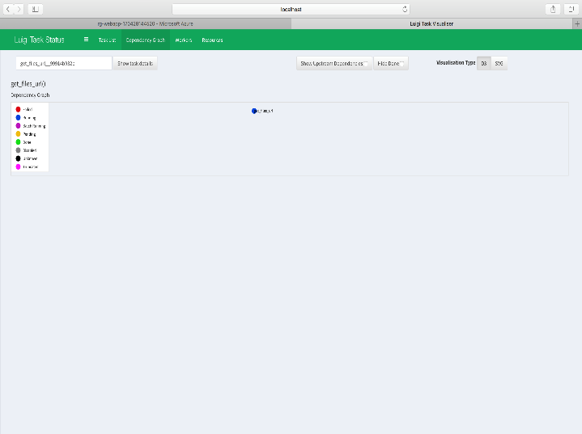

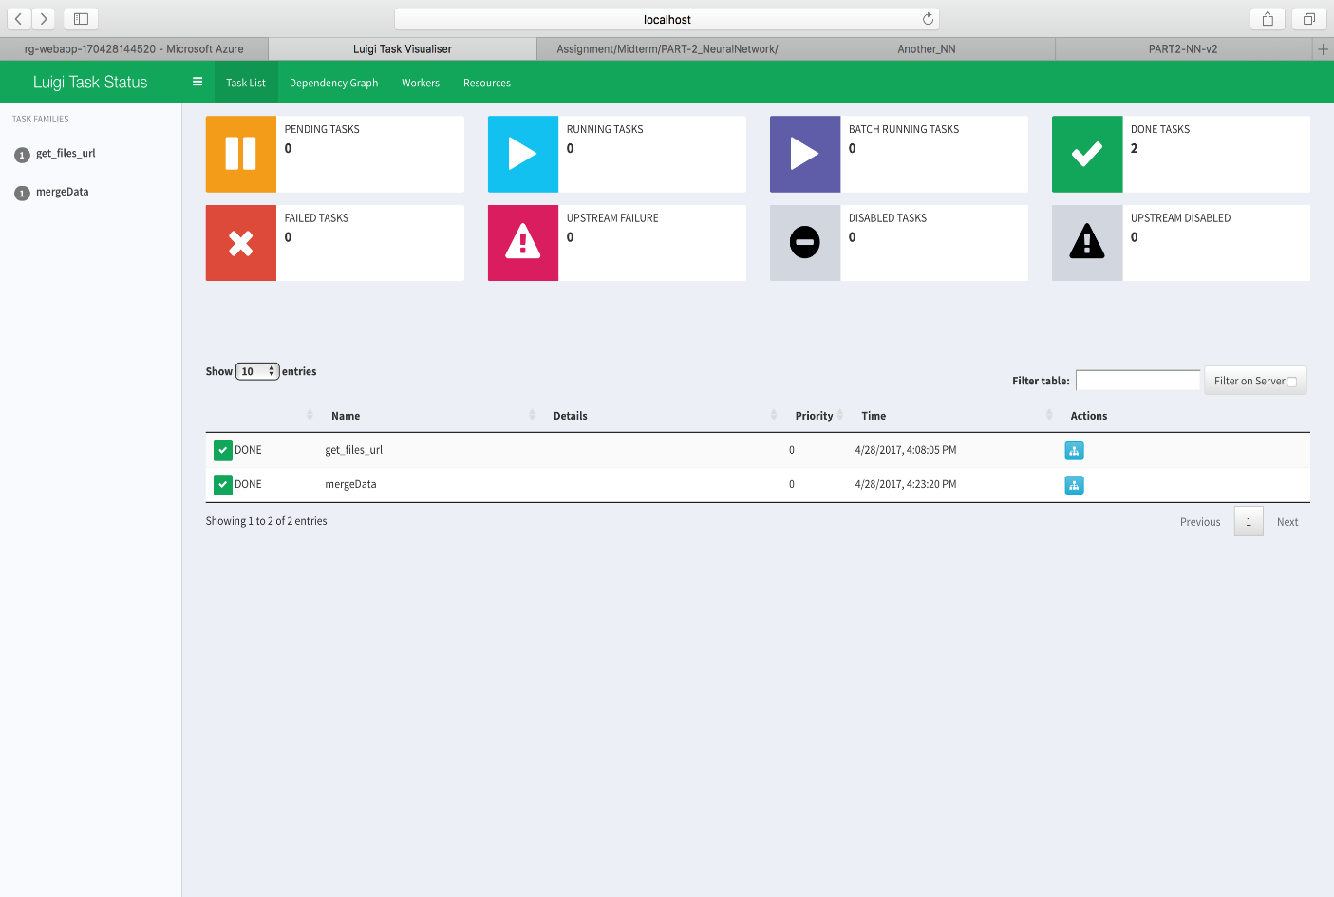

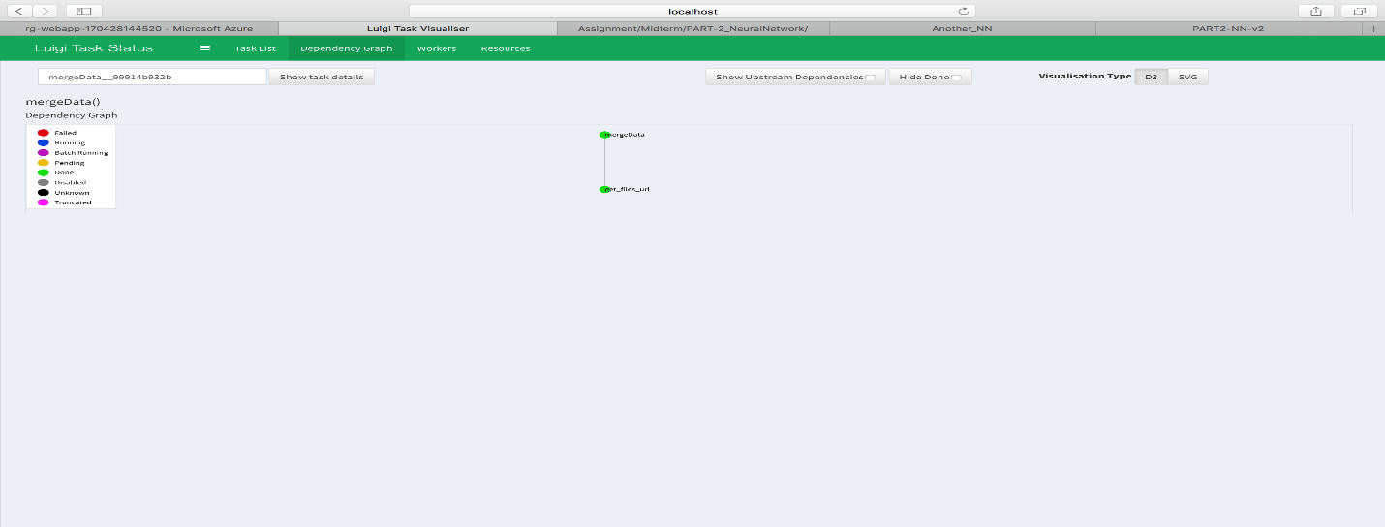

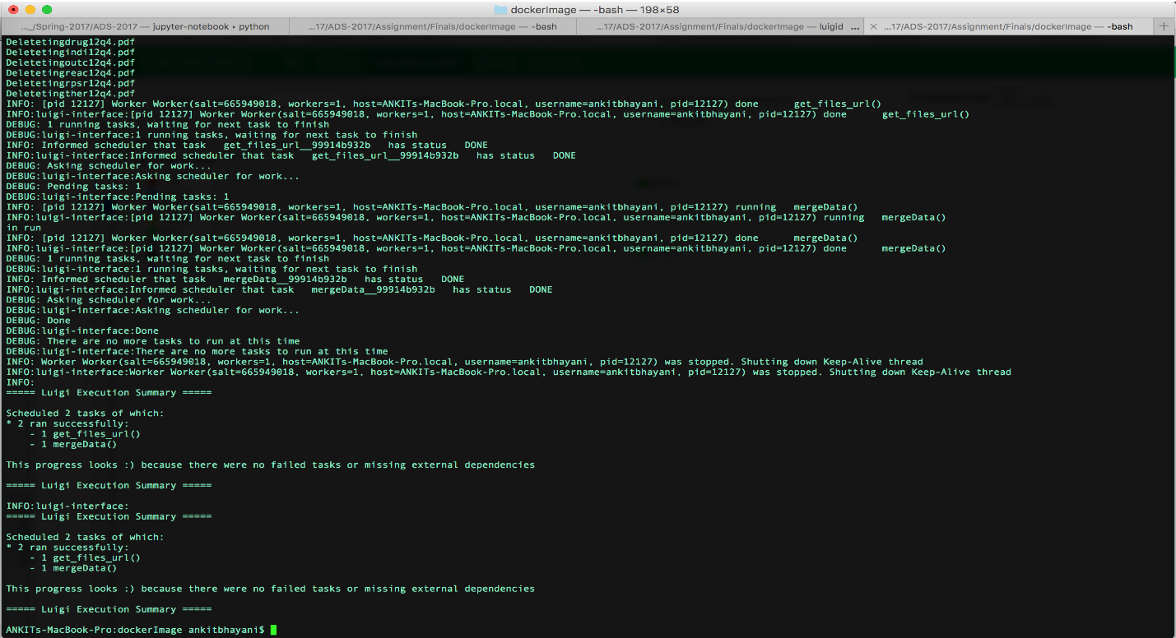

**DOCKER STEPS AND PROCESS**

**STEP 1:**

**CREATE THE DOCKER IMAGE FROM DOCKERFILE**

* 1. After taking the base UBUNTU 14.04 image.

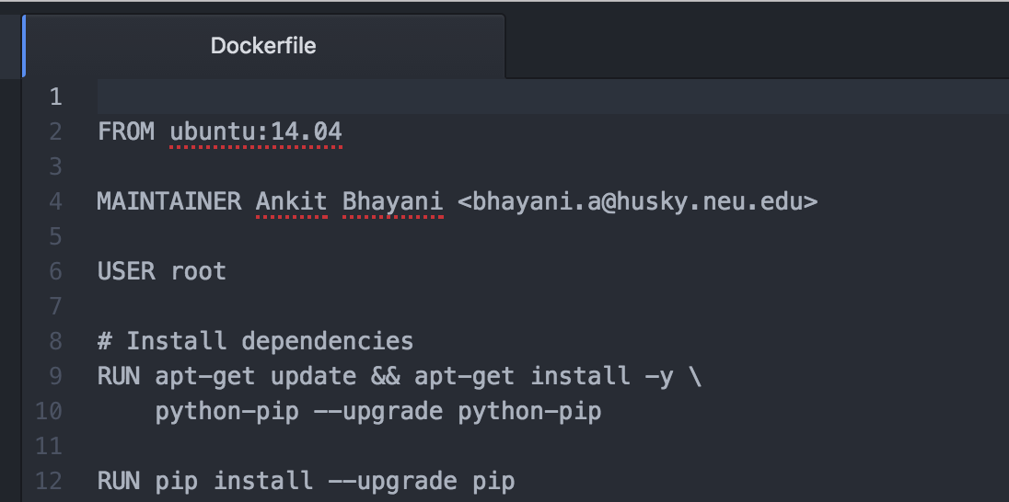

* 1. Install Python and all required packages which is used in source code

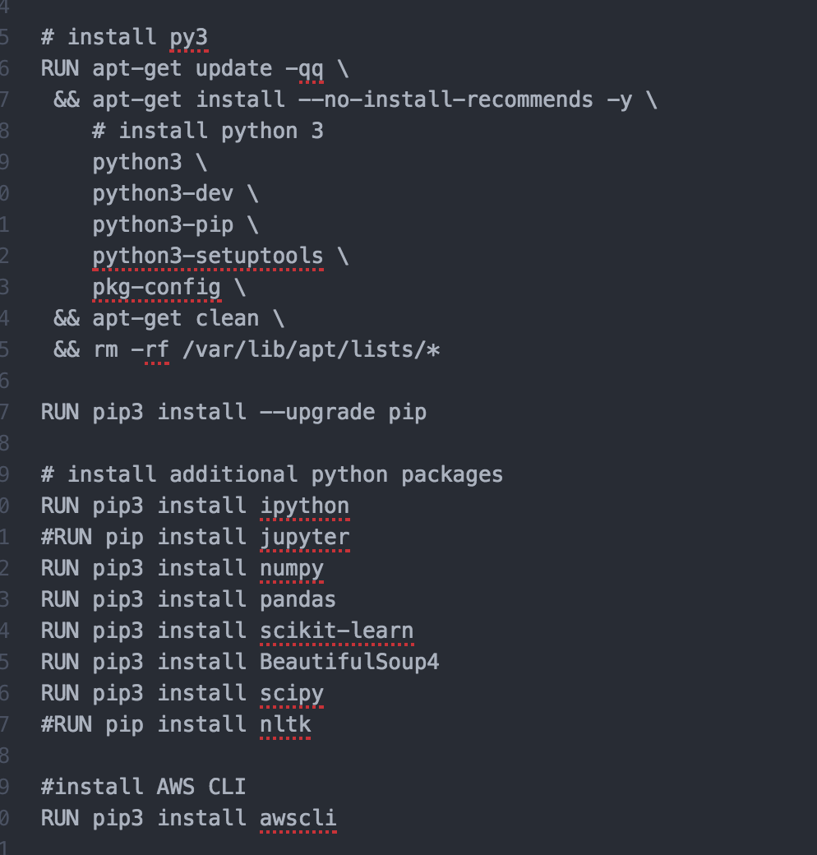

* 1. While building Docker File; First creating the work directory and then copying the source python and shell files from local machine to DOCKER image.

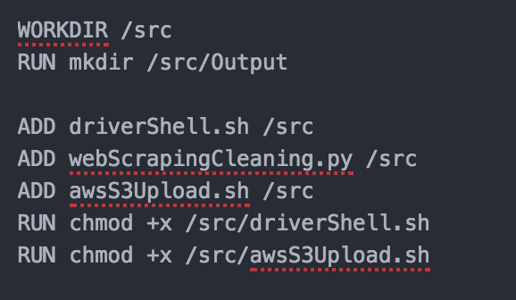

**STEP 2:**

**BUILD THE DOCKERFILE TO CREATE THE DOCKER IMAGE**

Building this Docker file will create a DOCKER image with name ankitbhayani/finalprojectads2017



Each step in this file will be executed in order to create an image. AWS CLI is also integrated inside the dockerfile

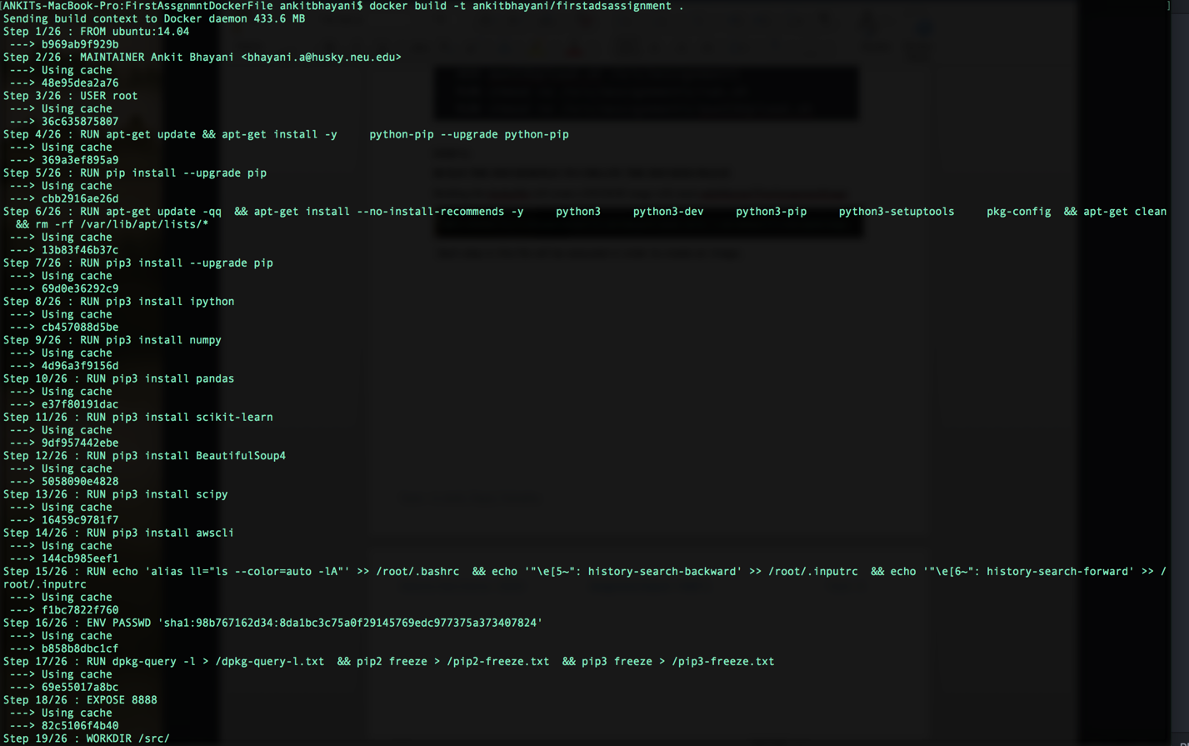

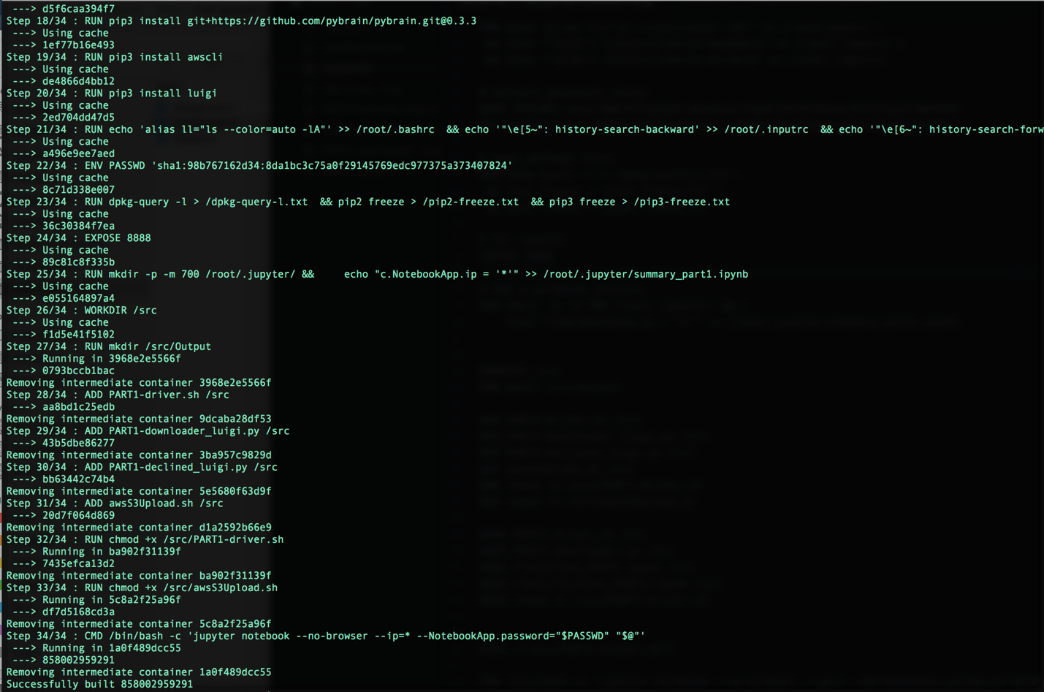

**STEP 3:**

**PUSH THIS DOCKER IMAGE to DOCKERHUB**

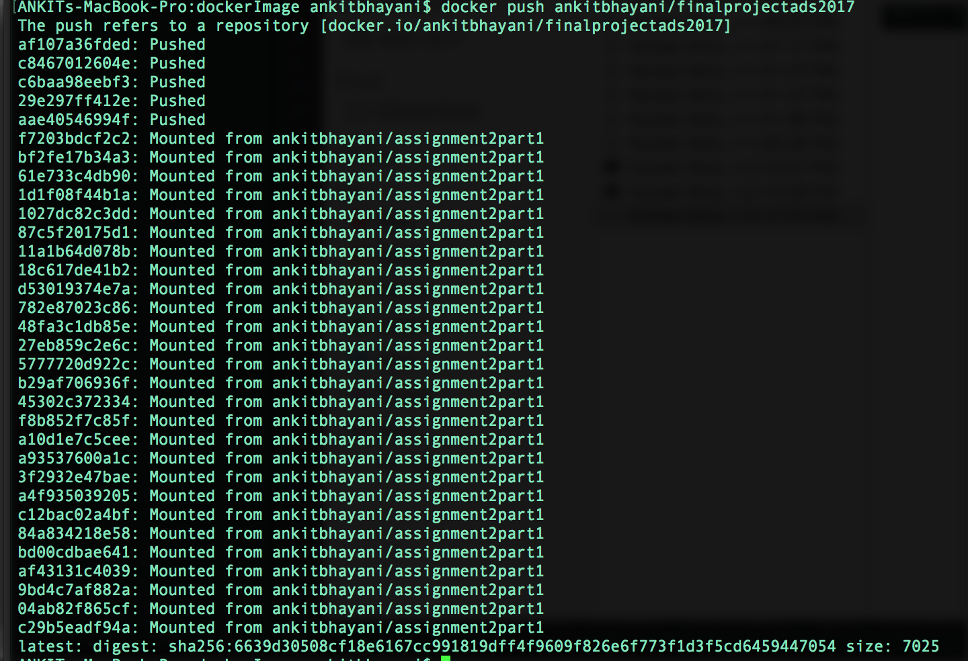

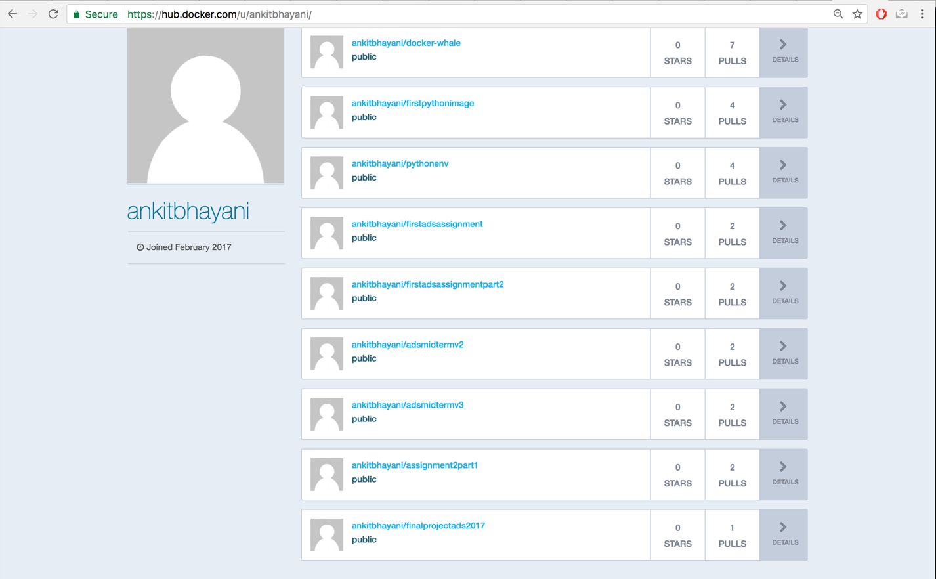

**STEP 4:**

**DOCKER RUN INSTRUCTIONS:**

**Pull an image from dockerhub:**

docker pull ankitbhayani/finalprojectads2017

**Run the docker image**

docker run -e ACCESS_KEY=**<YOUR_ACCESS_KEY>**

-e SECRET_KEY=**<YOUR_SECRET_KEY>**

-e S3_PATH=**<YOUR_S3_PATH>**

-e REGION=**<BUCKET_REGION>**

ankitbhayani/finalprojectads2017

/src/driverShell.sh

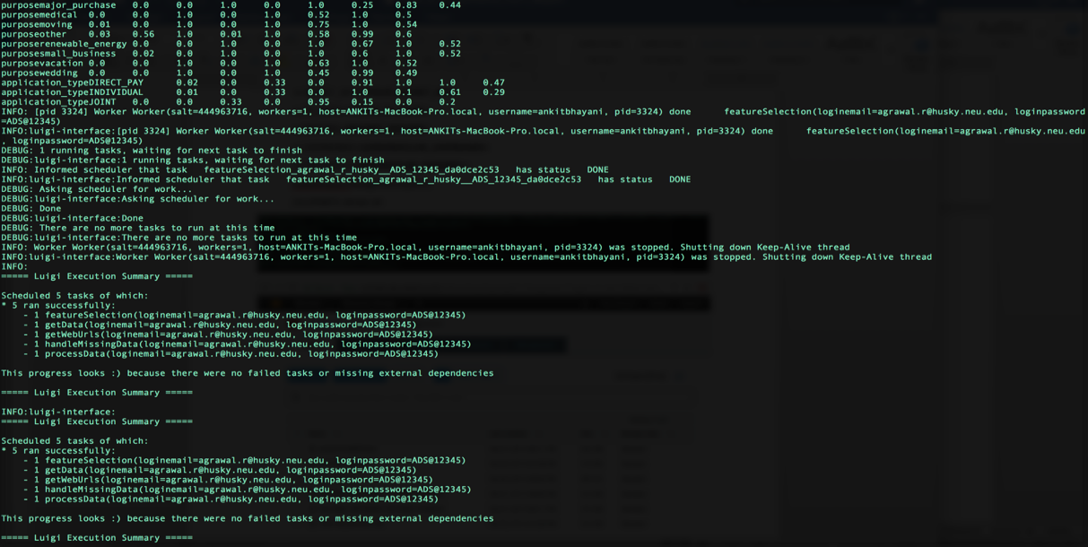

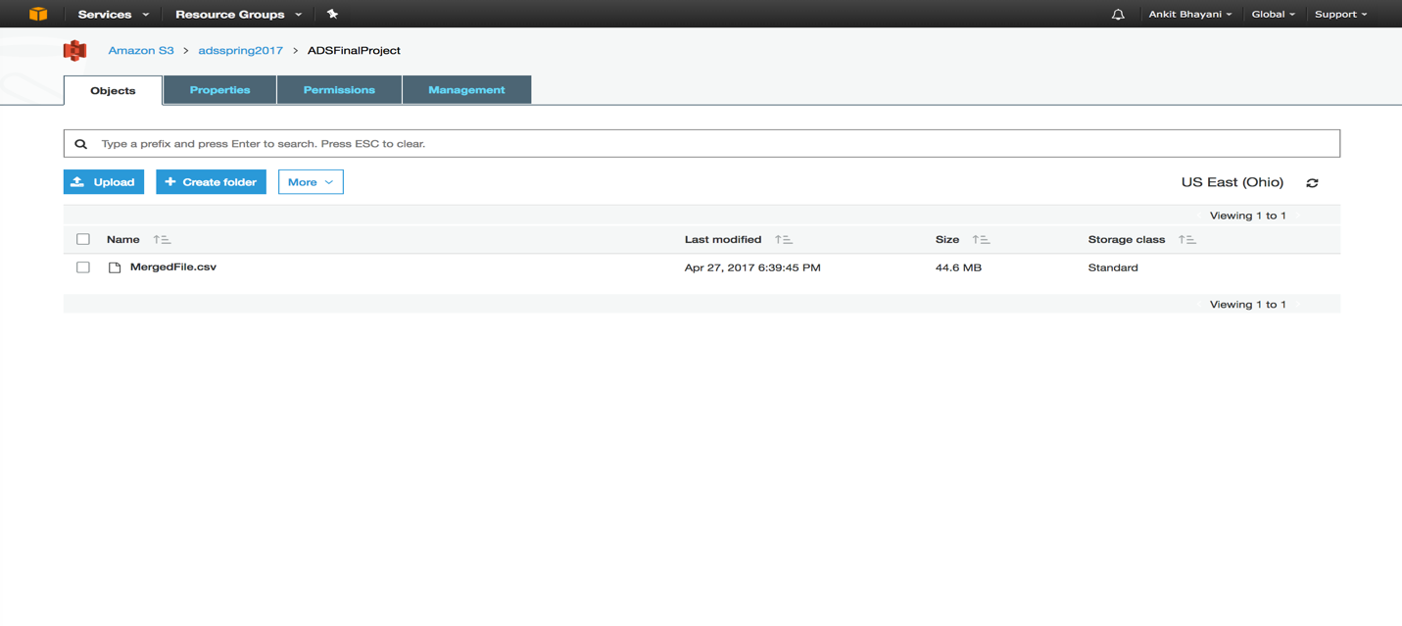

**DRIVER CODE HANDLING THROUGH SHELL FILE:**

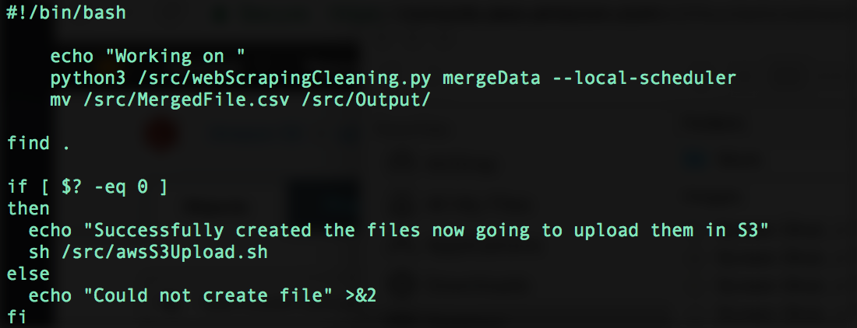

**AWS S3 UPLOAD SHELL FILE:**

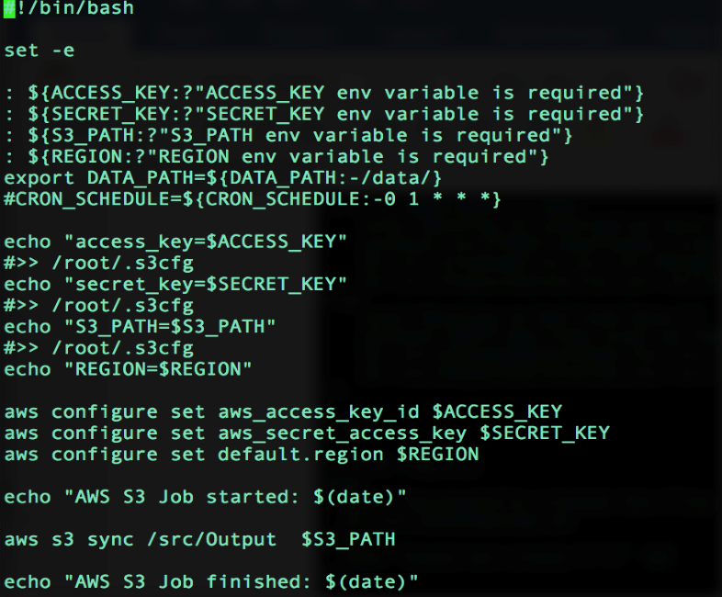

**MULTI - CLASS CLASSIFICATION**

**What Is Multiclass Classification?**

Each training point belongs to one of N different classes. The goal is to construct a function which, given a new data point, will correctly predict the class to which the new point belongs.

In our cleaned FAERS dataset, we have a column named **outc_cod**, which signifies the primary outcome for e.g. (‘OT’,’DE’) drug intake and reaction occurs. In our project, we are using multi-class classification to predict the probability of the outcome based on features selected from feature engineering.

CODE MEANING_TEXT

---- ------------

DE Death

LT Life-Threatening

HO Hospitalization - Initial or Prolonged

DS Disability

CA Congenital Anomaly

RI Required Intervention to Prevent

Permanent Impairment/Damage

OT Other

3.3 GENERIC APPROACH: CLASSIFCATION

 As we have already cleaned the FAERS data file, we will be using the same file for our model training and testing.

We will use three approaches to find out the outcome of our classification model:

* Using Azure ML Studio (For selecting the best model for our problem)
* Using Amazon ML web service (uses **Stochastic gradient descent**)
* Python Sklearn Library to test Neural Network

3.1.3 FEATURE SELECTION

Before proceeding with our models, we have done feature selection using **Chi Squared method**.

The best features that add to the predictive power of the model will be retained and irrelevant features removed from the model.

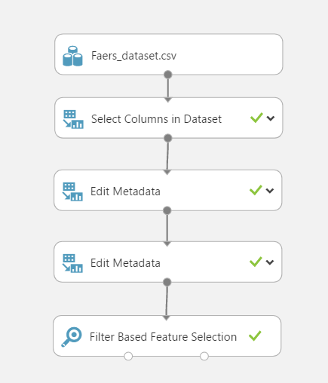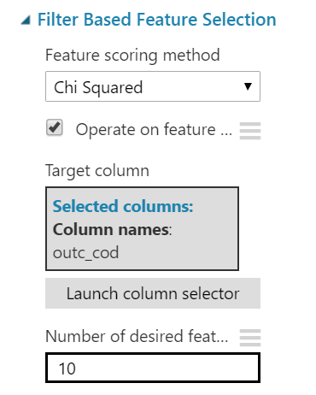

We have the selected variables as per the **Chi squared Method** and used those for further analysis while making sure that all the datasets contain same number of columns. Performing all the feature selection methods we shortlisted below features to best predict our model.

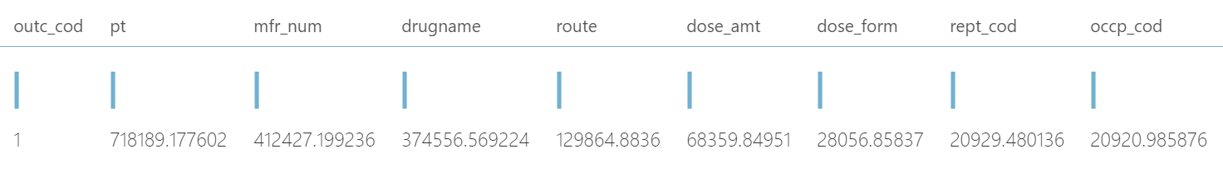

Now, we will discuss the algorithm used in the below section for all the Machine Learning algorithm used for classifications

3.3.1 DIFFERENT MACHINE LEARNING ALGORITHMS AND OUTPUT

We have used the following Algorithm for our Multiclass classification problem namely:

* **Multiclass Logistic Regression**
* **Multi-class Decision Forest**
* **Multiclass Neural Network**
* **One vs All Multiclass using SVM**

We trained all the four-model using Hyper Parameter Tuning (*Performs a parameter sweep on a model to determine the optimum parameter settings*) to get the best model result based on different parameters.

**Multiclass Logistic Regression**

Multiclass logistic regression is used when the [dependent variable](https://en.wikipedia.org/wiki/Dependent_variable) in question is [nominal](https://en.wikipedia.org/wiki/Level_of_measurement#Nominal_measurement) (equivalently categorical, meaning that it falls into any one of a set of categories which cannot be ordered in any meaningful way) and for which there are more than two categories.

**Result evaluation**

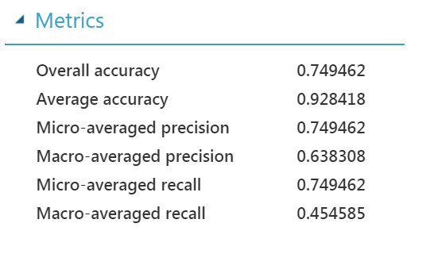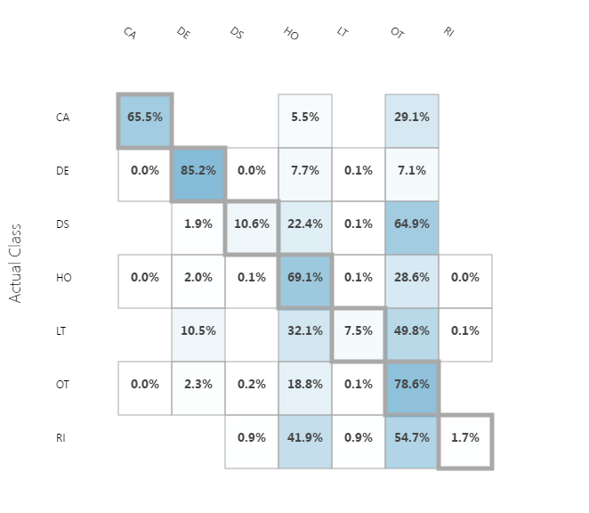

**Multi-class Decision Forest**

We can use the **Multiclass Decision Forest** module to create a machine learning model based on the *decision forest* algorithm. A decision forest is an ensemble model that very rapidly builds a series of decision trees, learning from tagged data.

**Result evaluation**

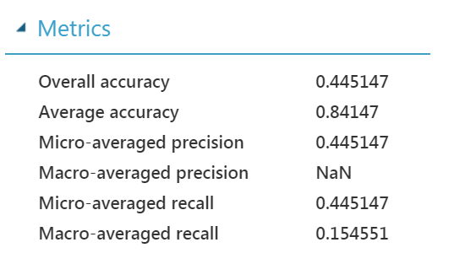 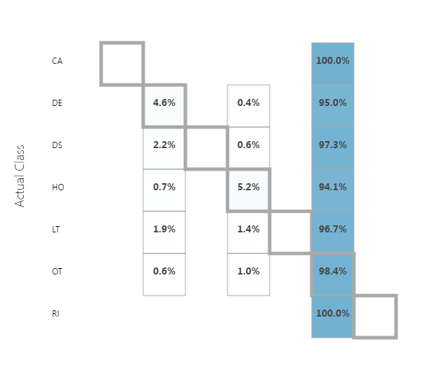

**Multiclass Neural Network**

We can use the **Multiclass Neural Network** module to create a neural network model that can be used to predict a target that has multiple values. For example, neural networks are frequently used in complex computer vision tasks, such as digit or letter recognition, document classification, and pattern recognition.

Classification using neural networks is a supervised learning method, and therefore requires a *tagged dataset* that includes a label column.

**Result evaluation**

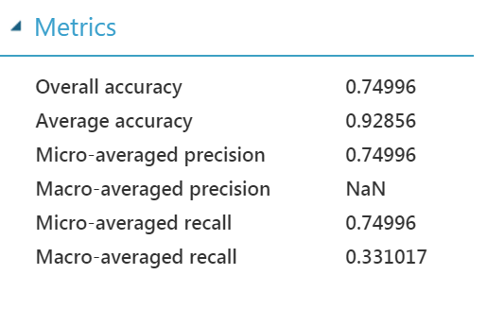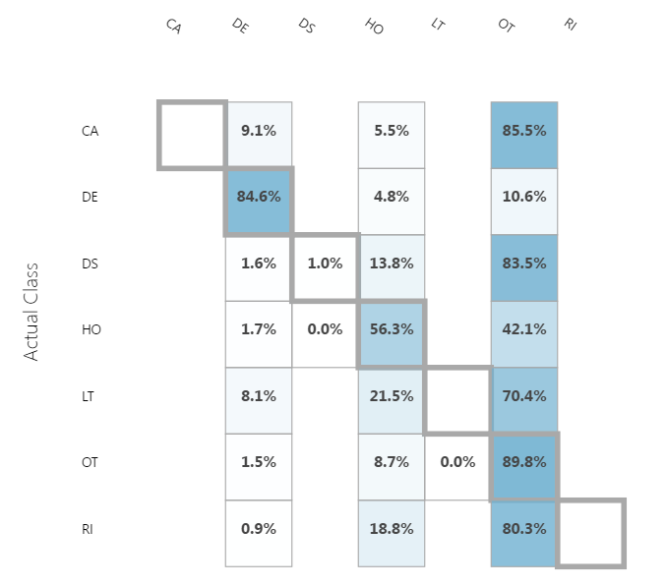

**One vs All Multiclass using SVM**

We can use the **One-Vs-All Multiclass** module to create a classification model that predicts multiple classes. This module is useful for creating models that predict three or more possible outcomes, when the outcome depends on continuous or categorical predictor variables. This method also lets us use binary classification methods for issues that require multiple output classes. To use this classifier, we connect it to an existing untrained two-class classification algorithm, and configure that model.

**Result evaluation**

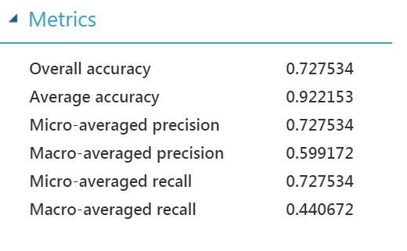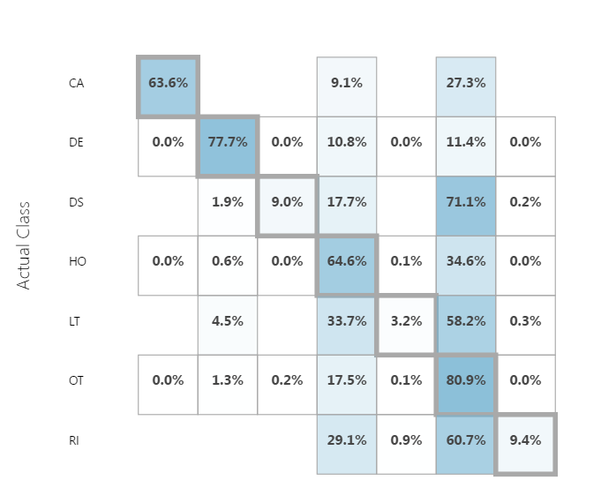

**IMPLEMENTING CLASSIFICATION MODEL ON AZURE ML**

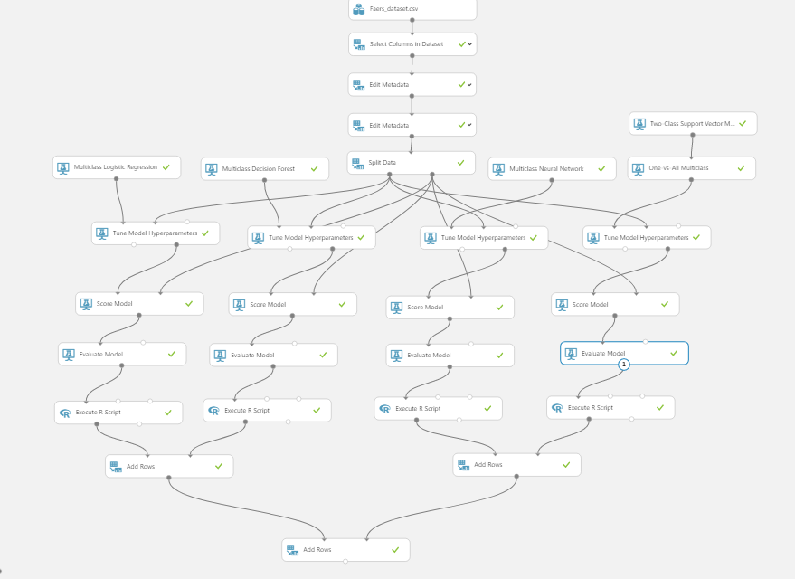

**Result Comparison**

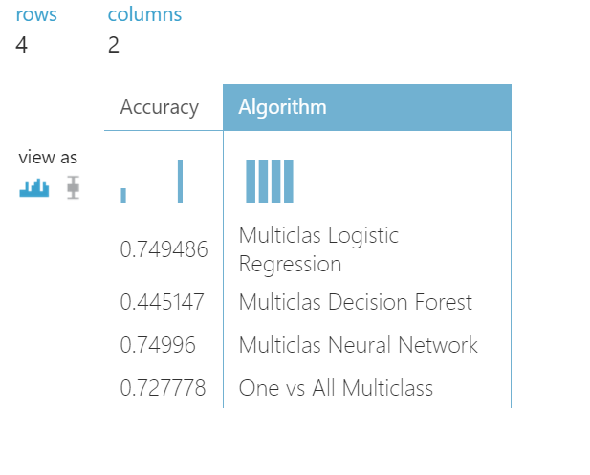

**SELECTING BEST MODEL FOR OUR PROBLEM STATEMENT**

After we run all the models, we select **Multiclass** **Neural Network** as our best trained Model to classify the outcome of the drug and Reaction with other factor affecting like Dosage Amount, frequency etc.

We have chosen this model based on the following parameters:

* Accuracy
* Recall

S E T U P W E B S E R V I C E : C L A S I F I C A T I O N

Our model upon setting up as web service looks like below, in this we have dragged our saved models.

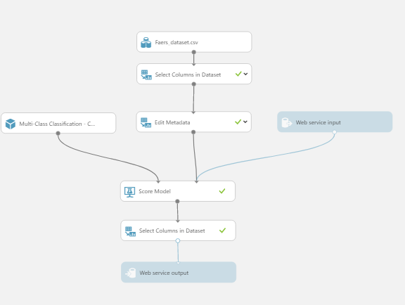

When we visualize the Score Model component we get scored labels and scored probabilities along with other features.

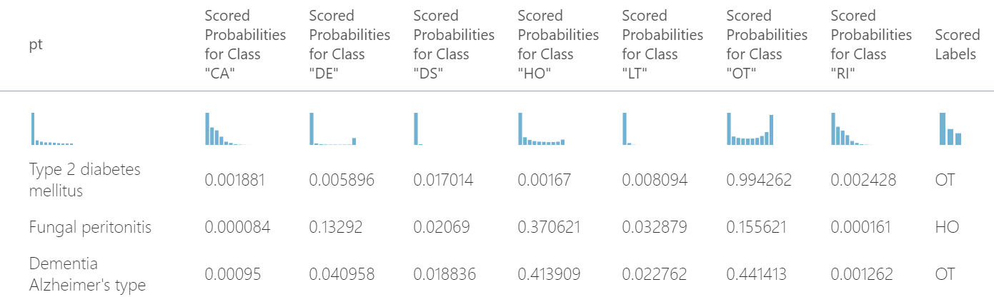

**Scored Probabilities:** We will consider taking this value as an output of web service to allow user to choose a value based on accuracy instead of using his own judgment.

We are using ‘Select Column in Dataset’ component to extract just these scored columns and predicted outcome class.

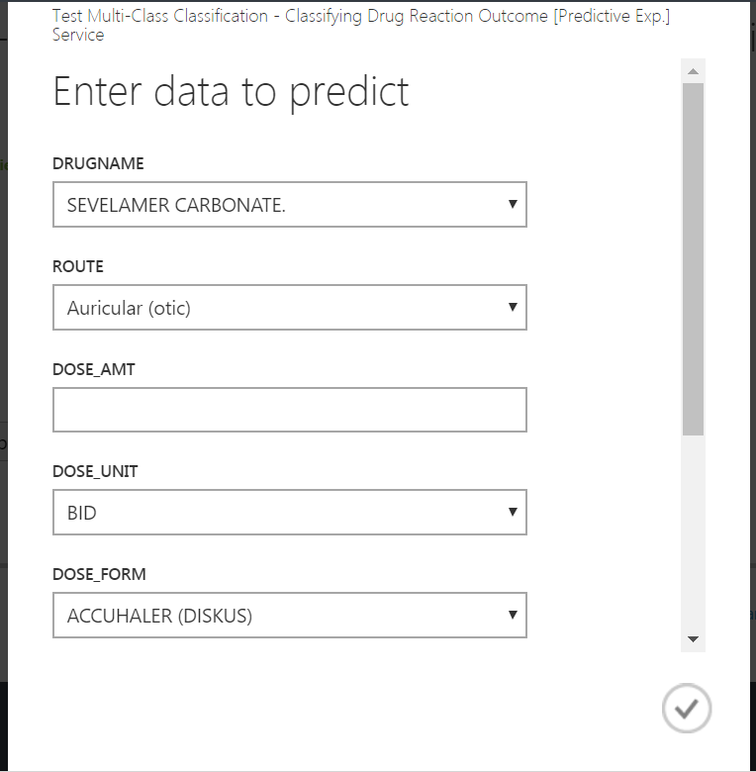

The output of this experiment is JSON format:

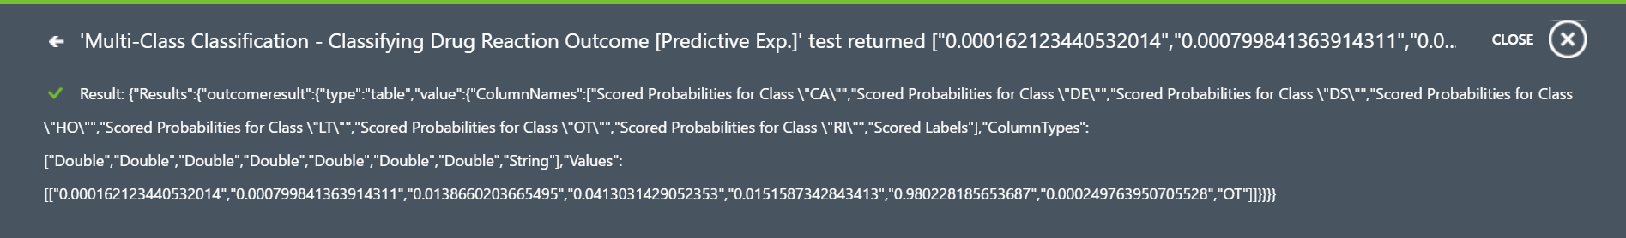

**AMAZON MACHINE LEARNING WEBSERVICE**

1. Taken the cleaned csv file(MergedFile.csv) from Amazon S3, which was uploaded by our PART-1 web scrapping and cleaning python script.

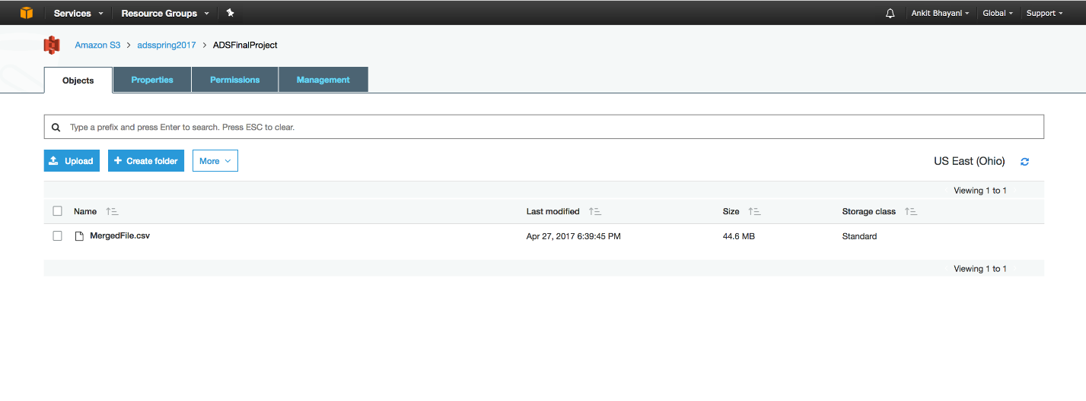

1. Created a data source and evaluated the correlated variables with respect to outcome.

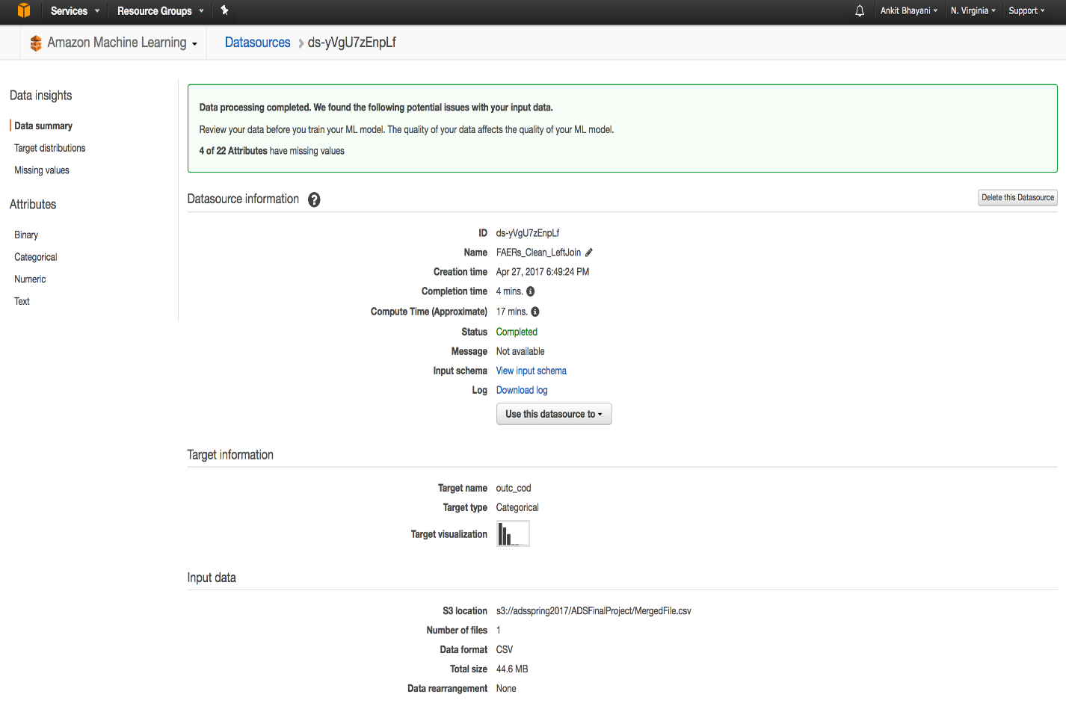

Outcome variable distribution

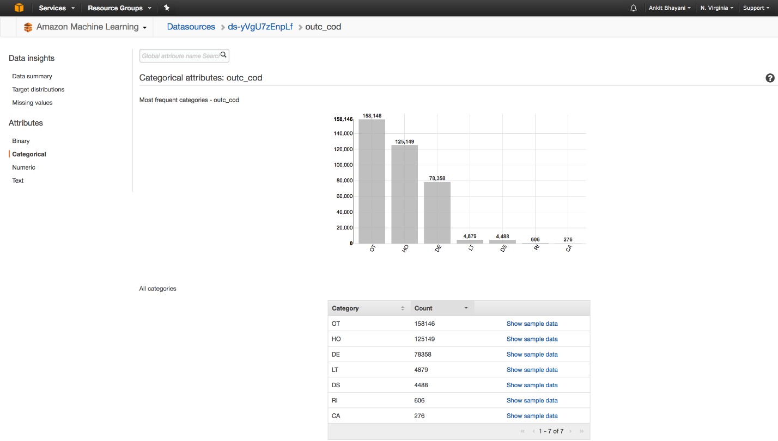

Correlation to target

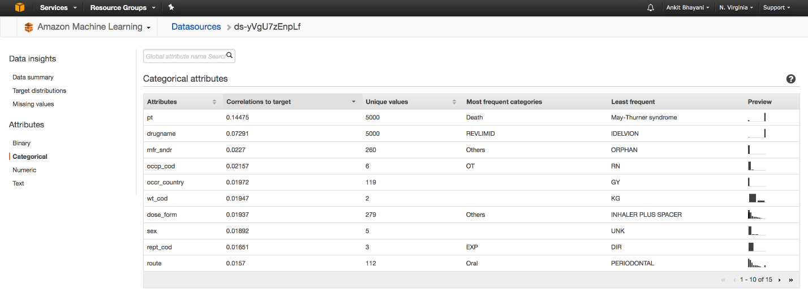

1. Trained a model with **L2-regularization technique** and inbuilt **SGD** learning algorithm.

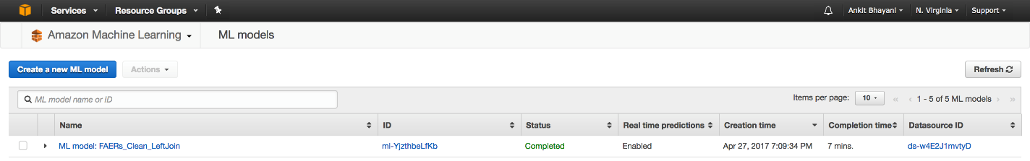

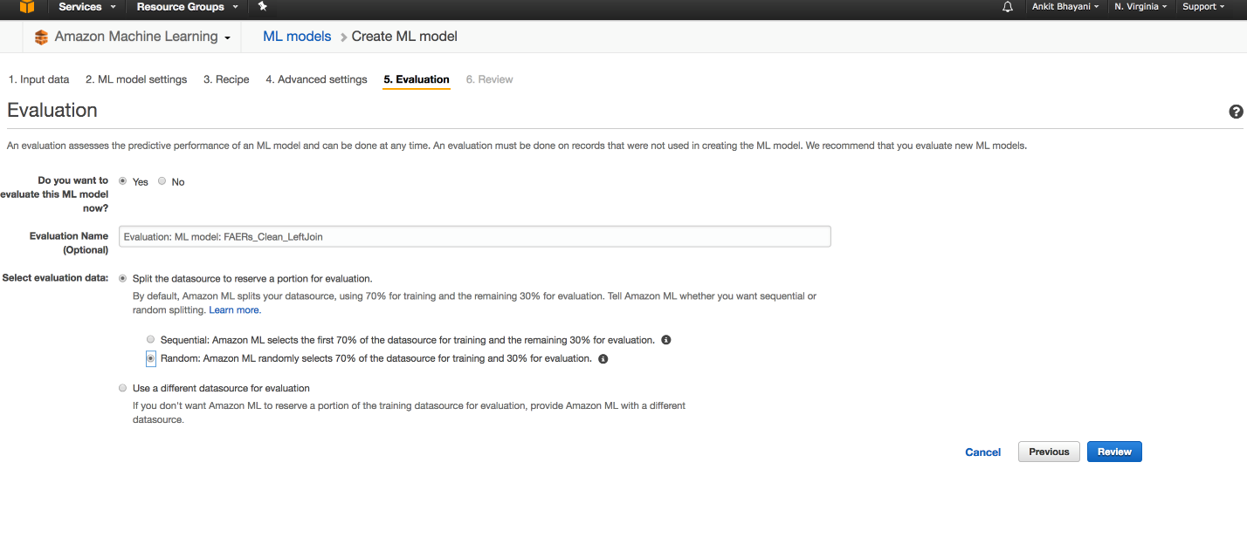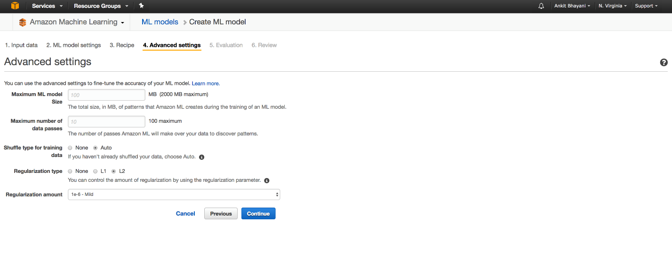

1. Evaluate the model performance.

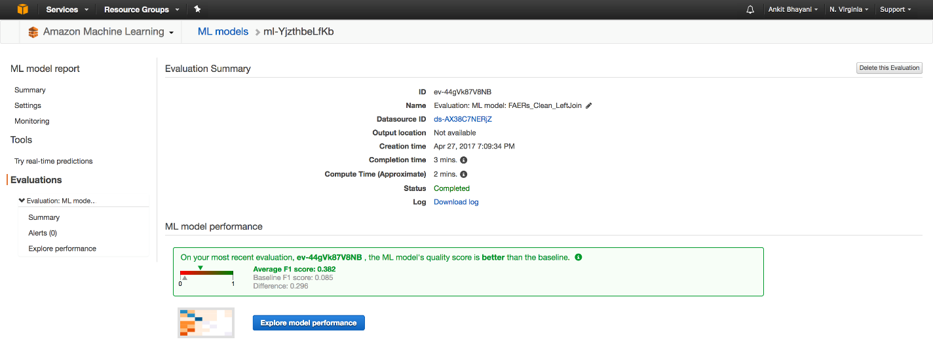

Confusion Matrix:

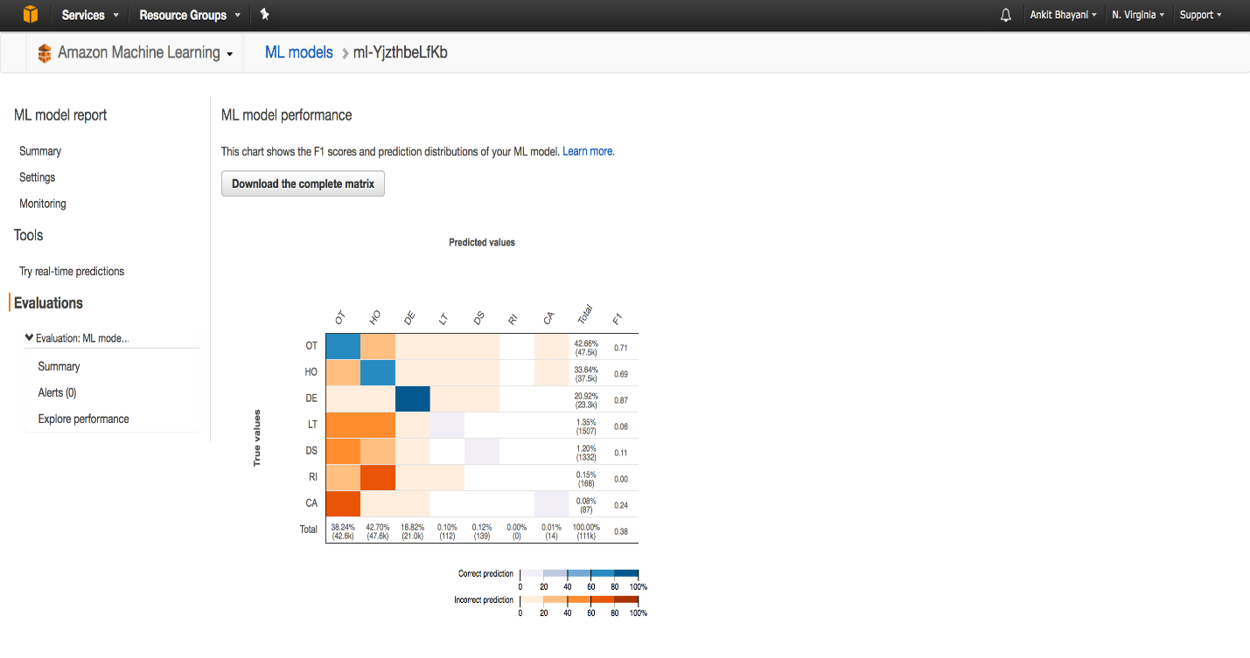

1. Tested our model with one of the existing rows inside input with **OUTCOME – HO (Hospitalization- highlighted)**

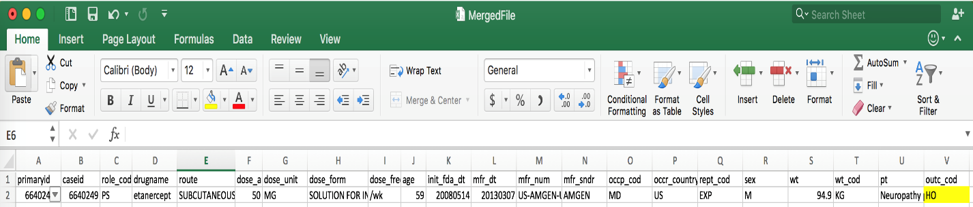

Output from Amazon ML – HO with 41% Scored probabilities

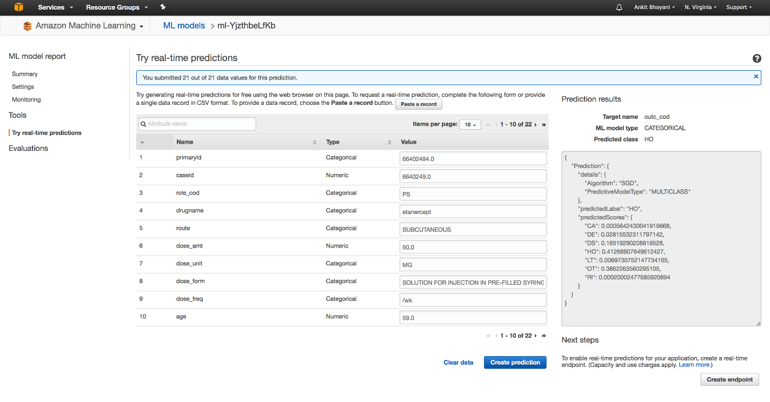

Enabled a real-end point URL (API) for the real time predictions.

URL: <https://realtime.machinelearning.us-east-1.amazonaws.com>

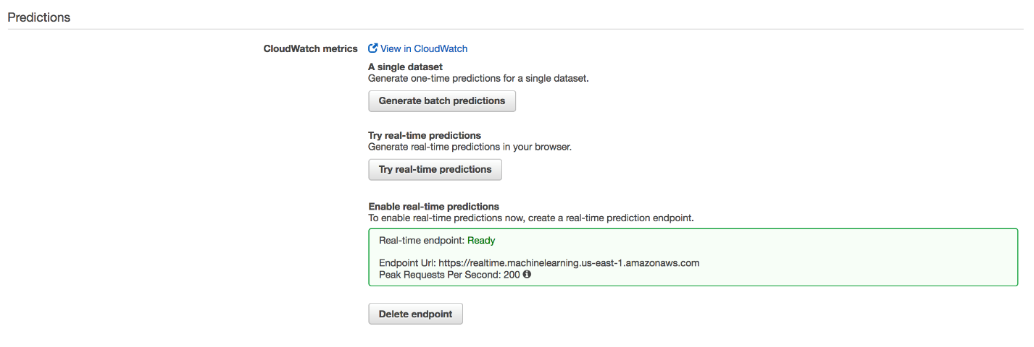

**SKLEARN – IMPEMENTING NEURAL NETWORK**

We Implement Network on Jupyter Notebook to the test the accuracy of our model and see the total error. To implement it, we install pybrain and add the following dependency:

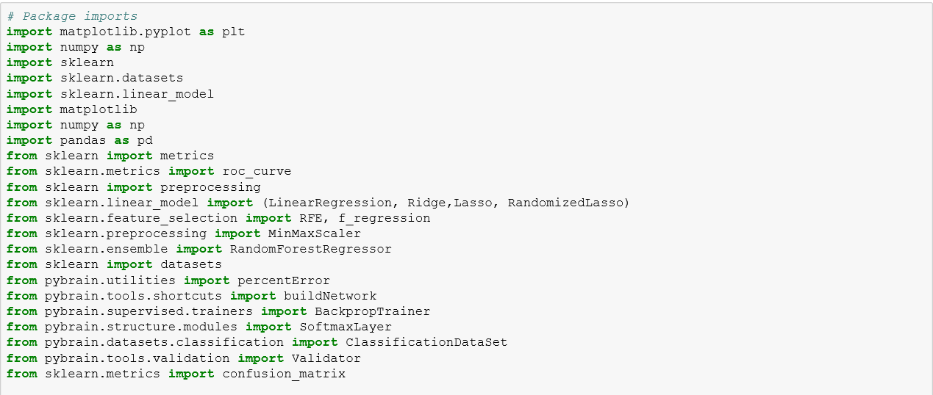

We will then select the best 10 features to train the model and verify result on the test data set to classify our outcome in on of the probable class.

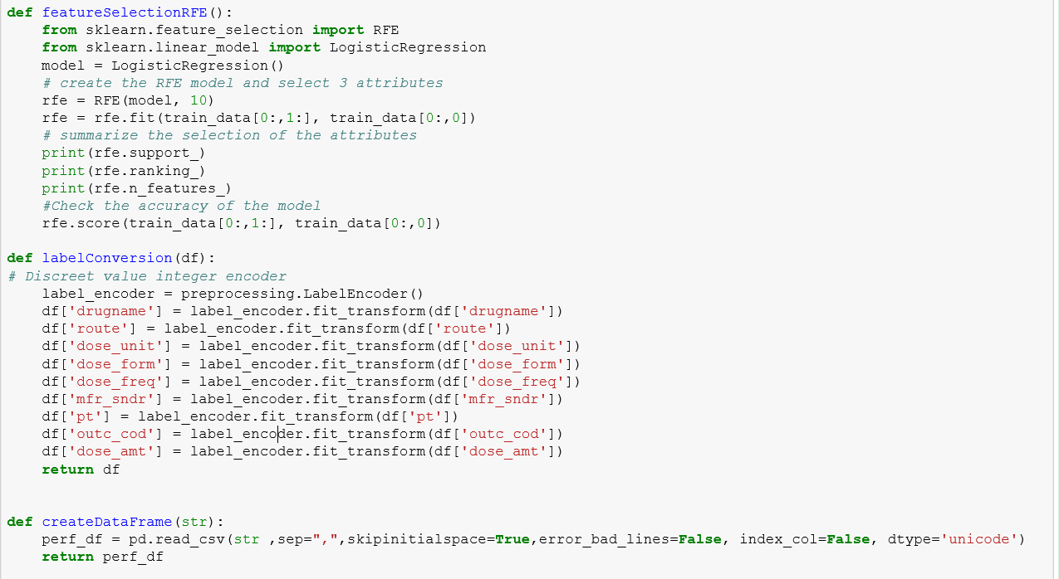

Now we will apply Neural Network Algorithm:

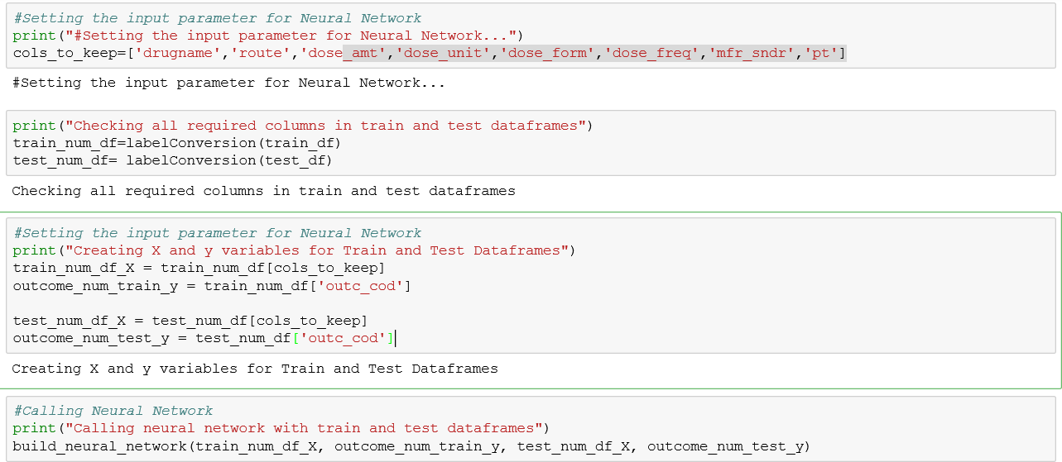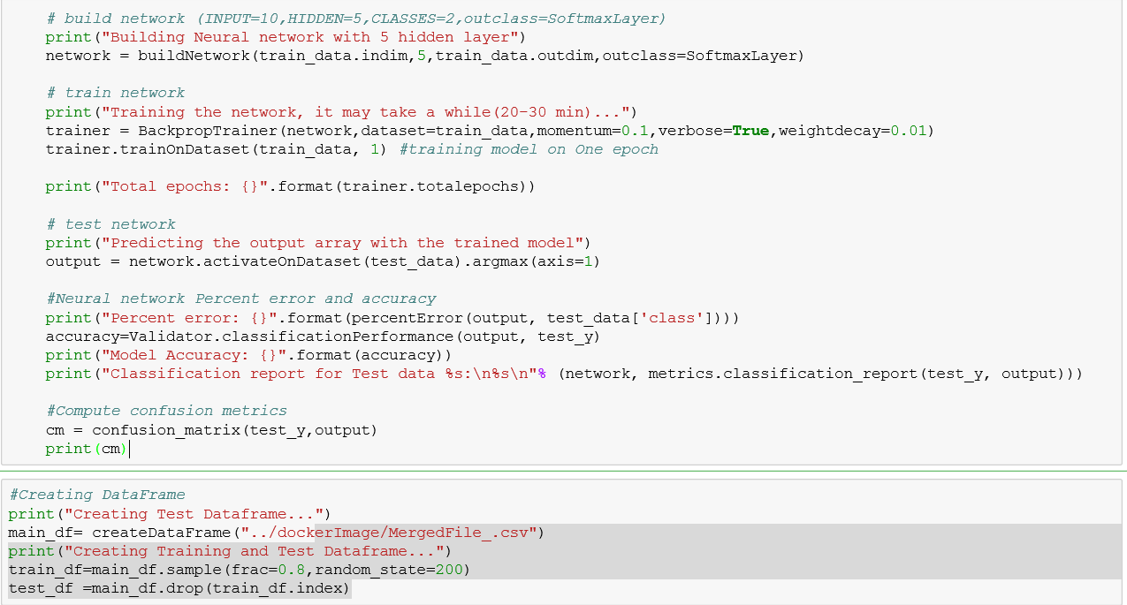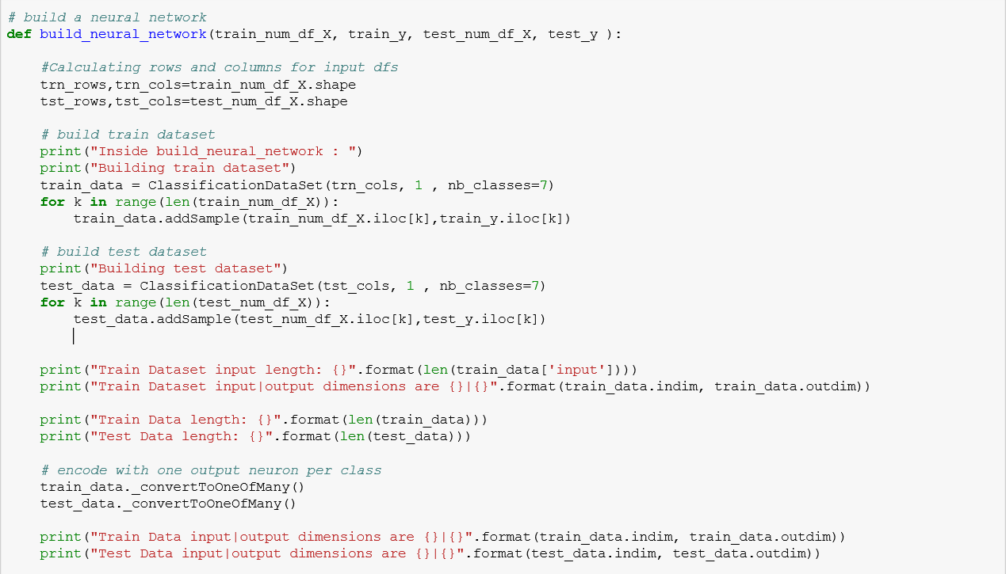

**RESULT:**

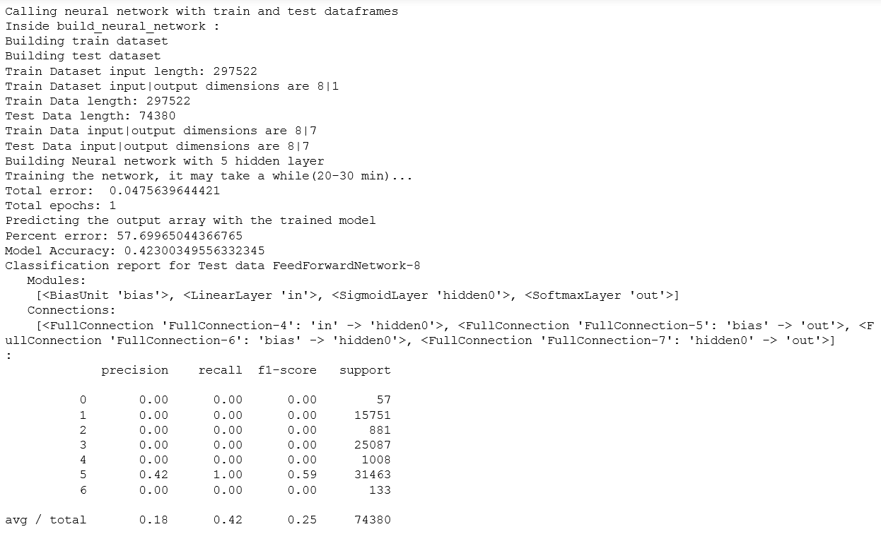

**FAERS OUTCOME CLASSIFICATION – WEB BASED SOLUTION**

**FAERS OUTCOME CLASSIFICATION** is a web-based interactive system for ADR detection and analysis.

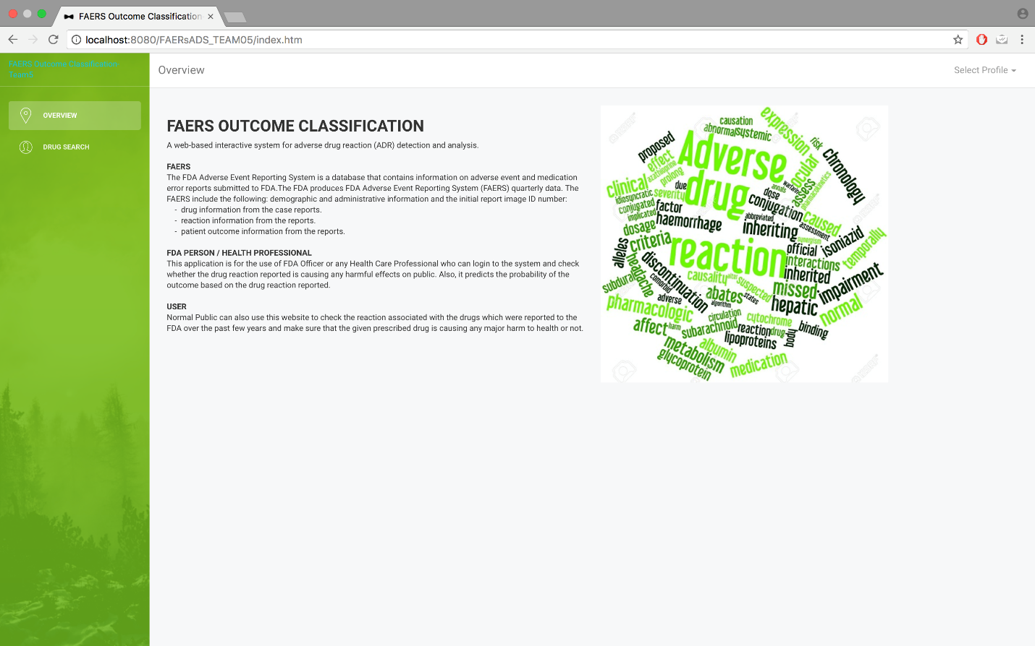

**FDA PERSON / HEALTH PROFESSIONAL**

This application is for the use of FDA Officer or any Health Care Professional who can login to the system and check whether the drug reaction reported is causing any harmful effects on public. Also, it predicts the

probability of the outcome based on the drug reaction reported.

**USER**

Normal Public can also use this website to check the reaction associated with the drugs which were reported to the FDA over the past few years and make sure that the given prescribed drug is causing any major harm to health or not.

**FDA PERSON / HEALTH PROFESSIONAL**

FDA Person will check on which drug reaction combination classification and its corresponding percentage distribution coming from ML model trained using Neural Network

FDA Person will select the following fields from the drop down:

* Drug Name
* Route
* Dose Amount
* Dose Unit
* Dose Form
* Dose Frequency
* Manufacture Details
* Reaction

He will get the following outcome:

* Scored Probabilities of all the Outcome caused by Drug/Reaction
* Hi-Charts showing the scored Probabilities

The one with Highest Scored Label will be classified as the predicted class of the input.

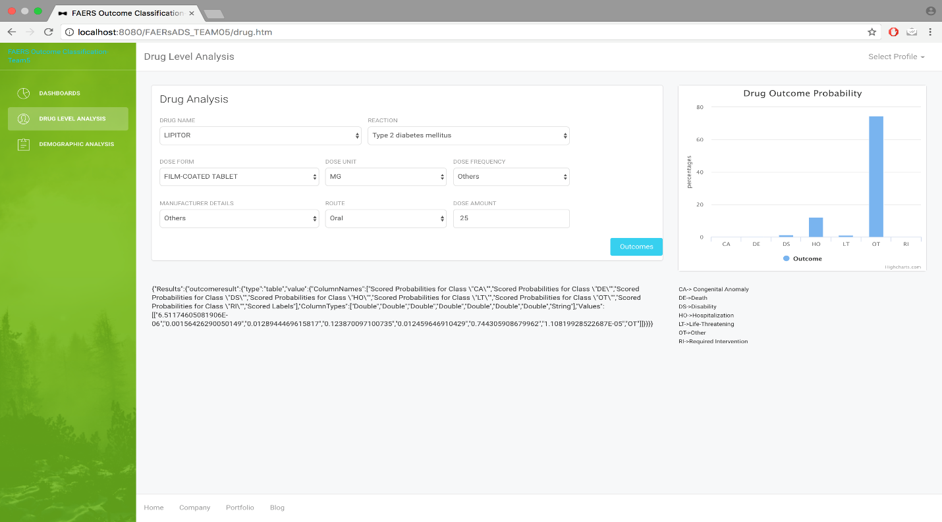

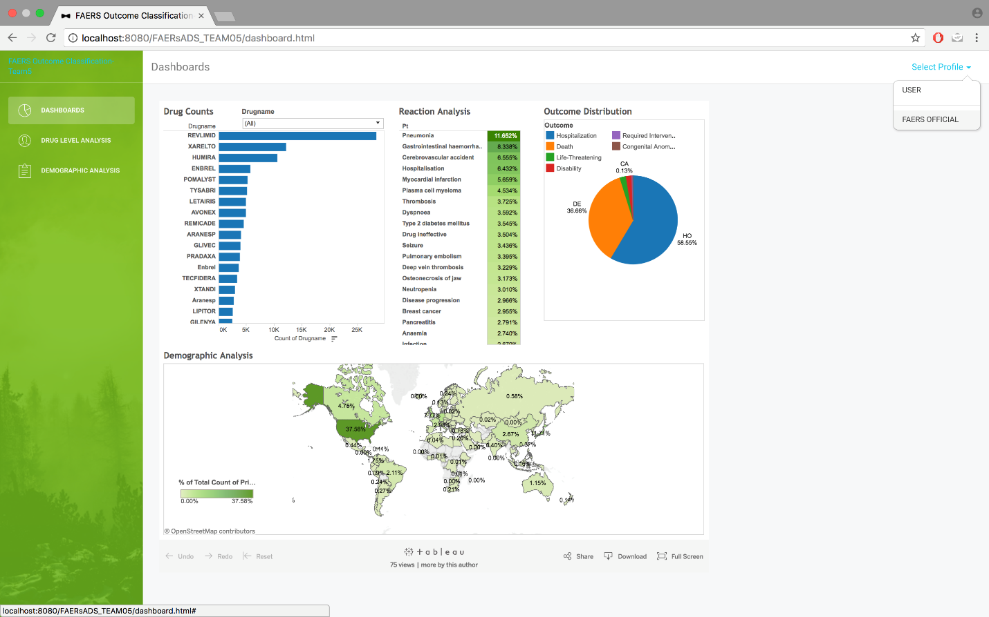

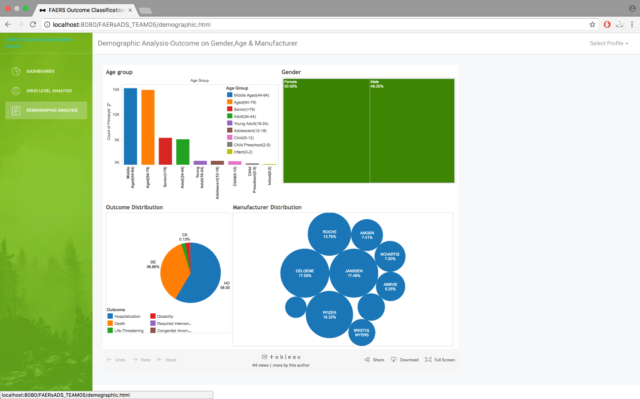

**User**

A normal user can visit the site and select the drug list from drop the list of drugs

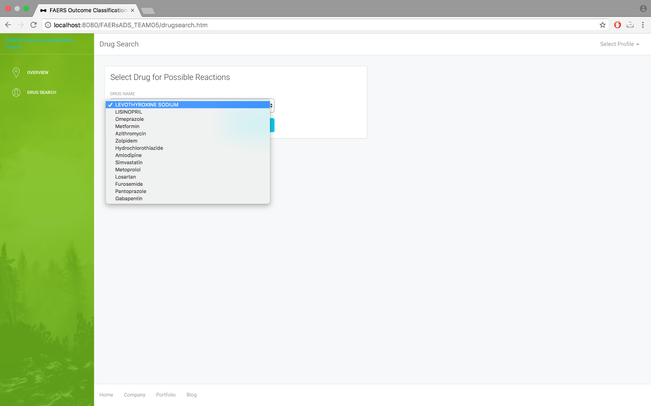

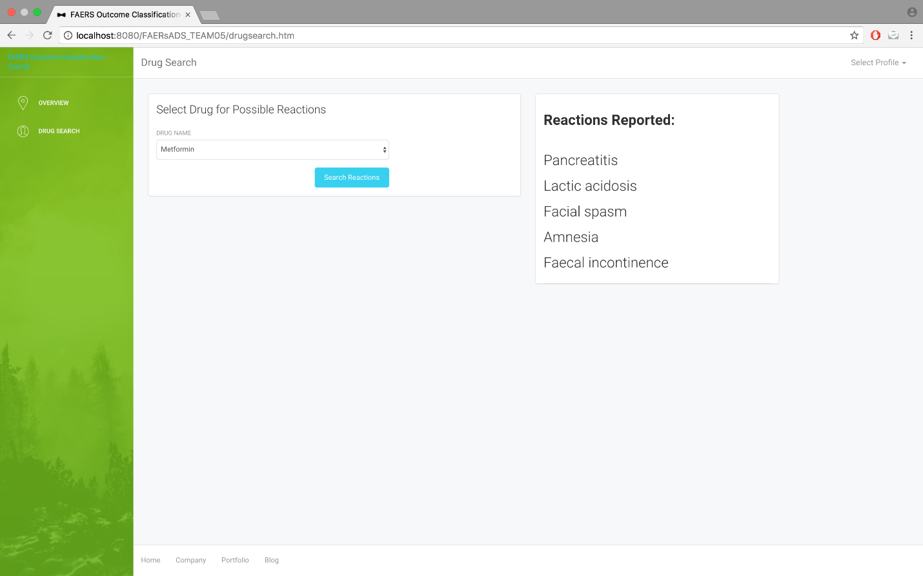

**RECORDS THAT ARE TESTED AGAIST THE APPLICATION**

|  |  |  |  |  |  |  |  |  |
| --- | --- | --- | --- | --- | --- | --- | --- | --- |
| **Drug Name** | **Route** | **Dosage amt** | **Dosage Unit** | **Dosage Form** | **Freq** | **Manufacture** | **Reaction** | **Outcome** |
| CANCIDAS | Intravenous drip | 70 | MG | INJECTION | QD | MERCK | Interstitial lung disease | DE |
| REVLIMID | Oral | 15 | MG | CAPSULES | QD | Others | Plasma cell myeloma | DE |
| JAKAFI | Oral | 5 | MG | TABLET | BID | INCYTE | Death | DE |
| EXELON PATCH | TRANSDERMAL | 4.6 | MG | TRANS-THERAPEUTIC-SYSTEM | Others | Others | Lung disorder | DE |
| TASIGNA | Oral | 300 | MG | CAPSULE | BID | Others | Completed suicide | DE |
| PRADAXA | ORAL | 110 | MG | CAPSULE, HARD | BID | Others | Cerebral haemorrhage | DE |
| SENSIPAR | ORAL | 30 | MG | TABLET | /hr | Others | Diarrhoea | DS |
| SPIRIVA | INHALATION | 18 | UG | INHALATION POWDER, HARD CAPSULE | Others | Others | Coronary artery occlusion | HO |
| RANOLAZINE | Oral | 1000 | MG | TABLET | Others | Others | Chest pain | HO |
| INVEGA | Oral | 6 | MG | OROS (ORAL OSMOTIC) THERAPEUTIC SYSTEM TABLET | Others | JANSSEN | Urinary tract infection | HO |
| Bevacizumab | Intravenous (not otherwise specified) | 952 | MG | SOLUTION FOR INFUSION | Q3W | ROCHE | Faecaloma | HO |
| Ranitidine (Unknown) | Oral | 150 | MG | UNK | BID | Others | Pancreatitis acute | HO |
| PEGYLATED COAGULATION FACTOR VIII | Intravenous (not otherwise specified) | 3996 | IU | POWDER FOR SOLUTION FOR INFUSION | 1X | BAXALTA | Oesophageal ulcer | HO |
| QUETIAPINE | ORAL | 1 | DF | TABLET | Others | Others | Loss of consciousness | OT |
| JAKAFI | ORAL | 20 | MG | TABLET | Others | Others | Blood count abnormal | OT |
| GILENYA | Oral | 0.5 | MG | CAPSULE | Others | Others | Central nervous system lesion | OT |

Reported Outcome



**Thank you.**

**WEBSITE FOR PATIENT (USER)**